Investigating with ELK 101

A US-based company **CyberT** has been monitoring the VPN logs of the employees, and the SOC team detected some anomalies in the VPN activities. Our task as SOC Analysts is to examine the VPN logs for January 2022 and identify the anomalies. Some of the key points to note before the investigation are:

* All VPN logs are being ingested into the index **vpn_connections**.
* The index contains the VPN logs for January 2022.
* A user **Johny Brown** was terminated on 1st January 2022.
* We observed failed connection attempts against some users that need to be investigated.
* **Elastic stack**
* Elastic stack is the collection of different open source components linked together to help users take the data from any source and in any format and perform a search, analyze and visualize the data in real-time.

**How they work together:**

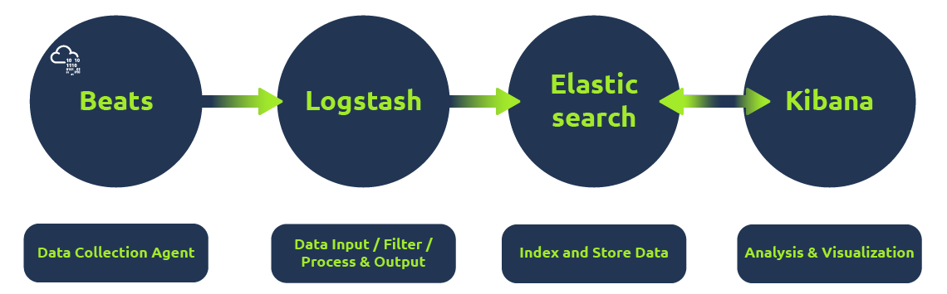

* Beats is a set of different data shipping agents used to collect data from multiple agents. Like Winlogbeat is used to collect windows event logs, Packetbeat collects network traffic flows.
* Logstash collects data from beats, ports or files, etc., parses/normalizes it into field value pairs, and stores them into elasticsearch.
* Elasticsearch acts as a database used to search and analyze the data.
* Kibana is responsible for displaying and visualizing the data stored in elasticsearch. The data stored in elasticseach can easily be shaped into different visualizations, time charts, infographics, etc., using Kibana.

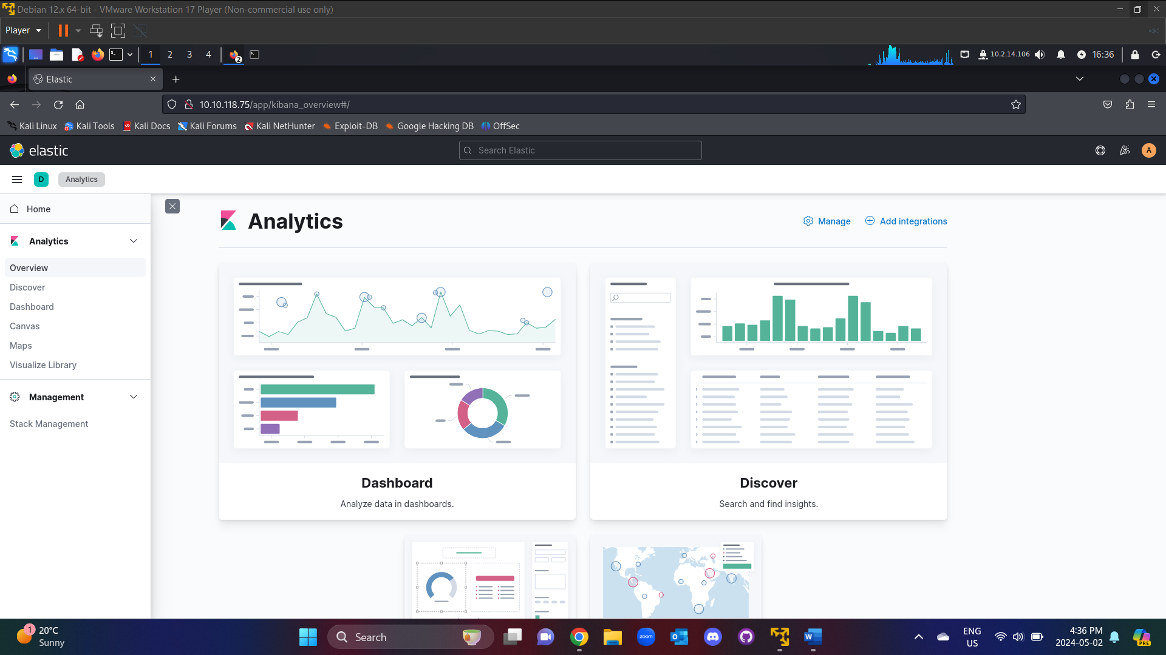

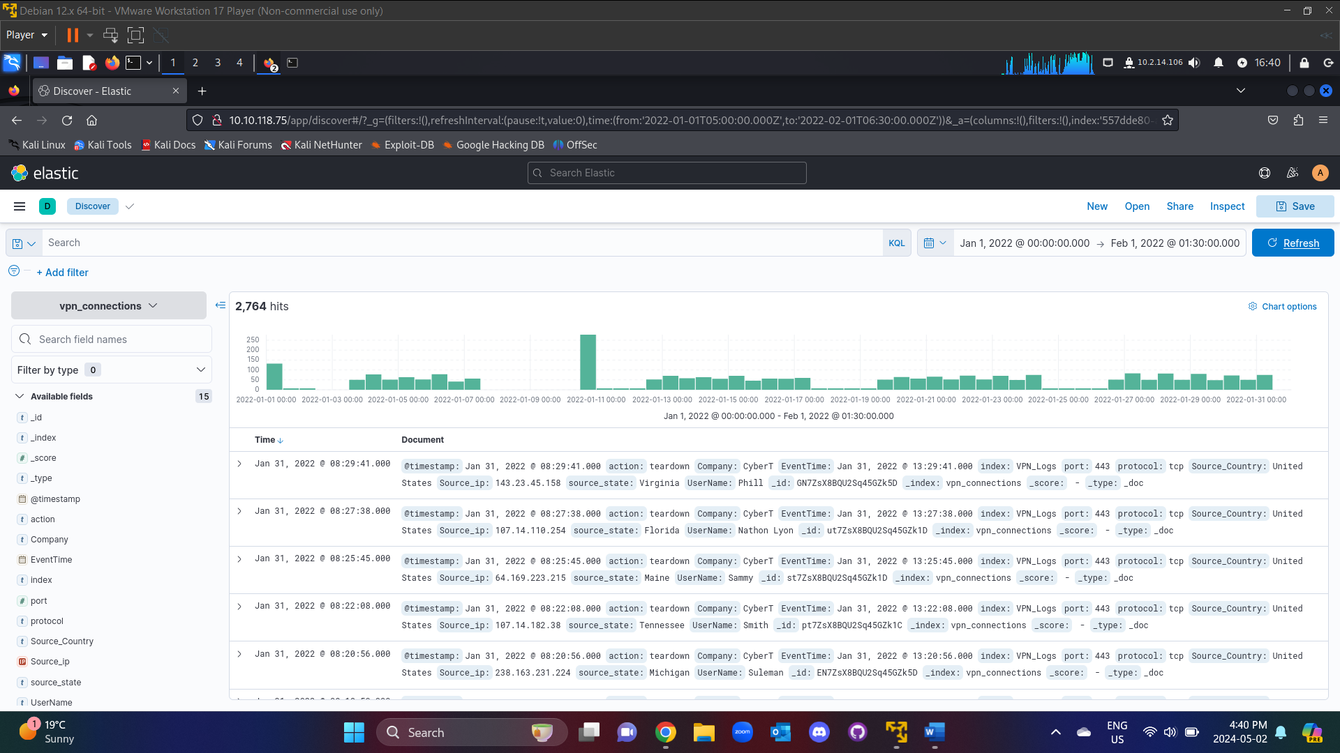

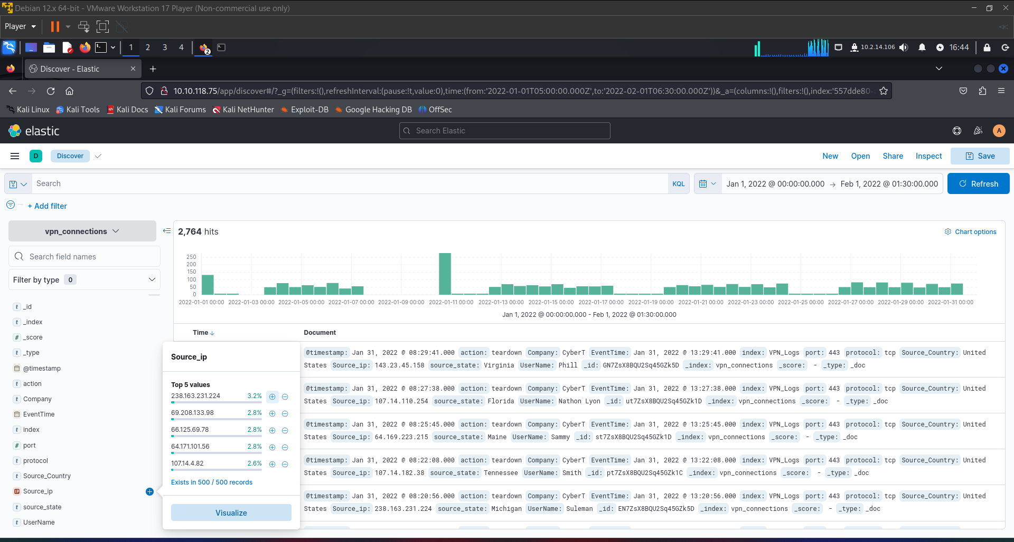

**Create Visualization**

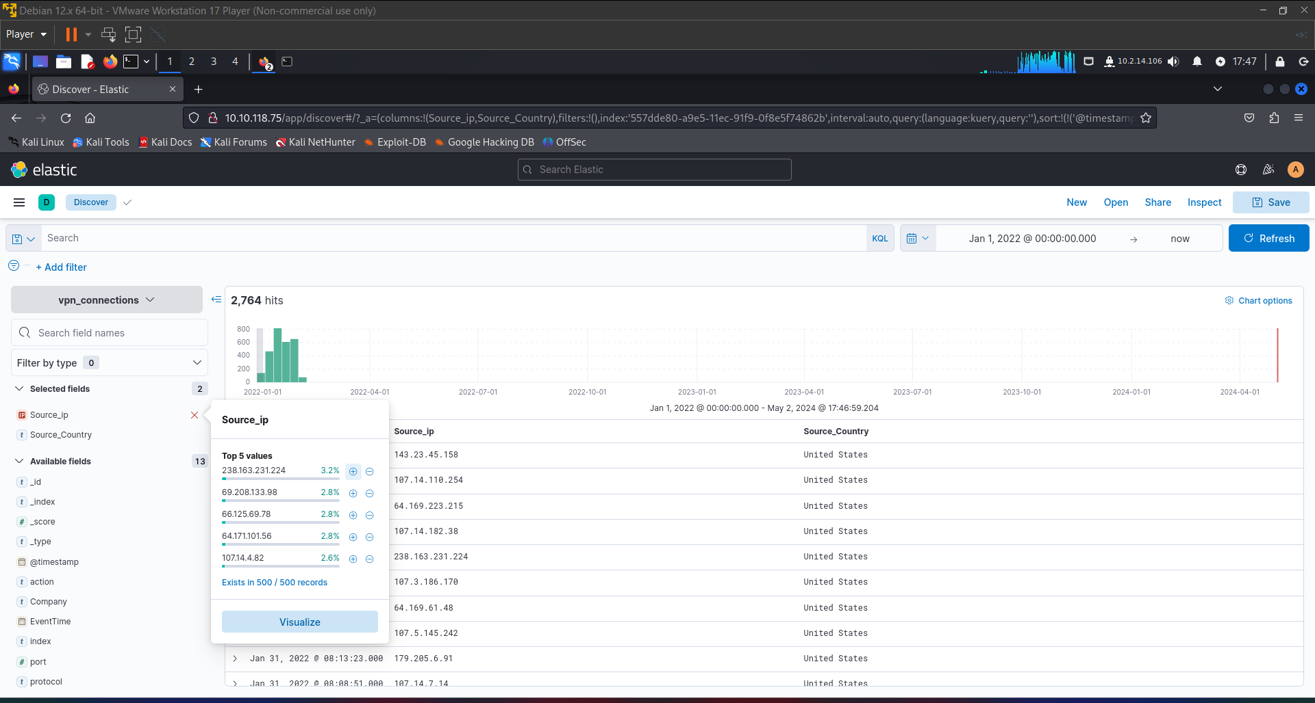

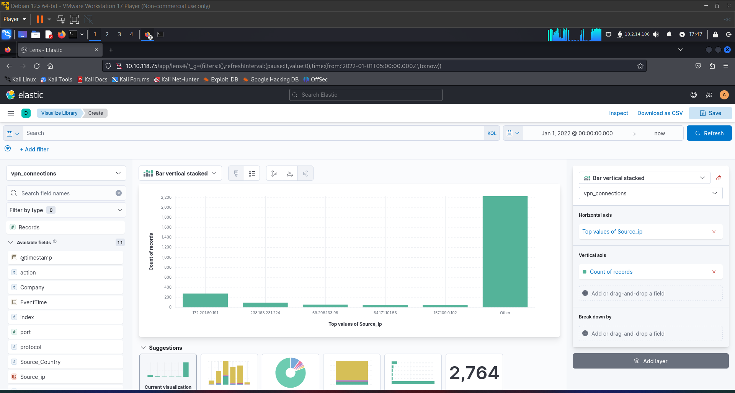

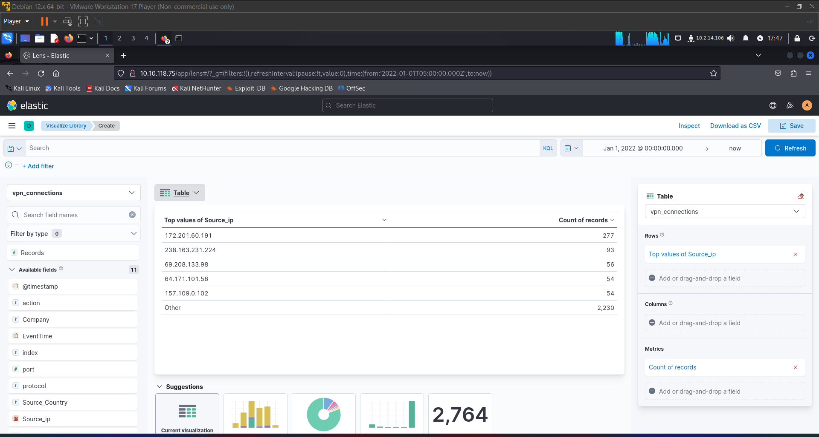

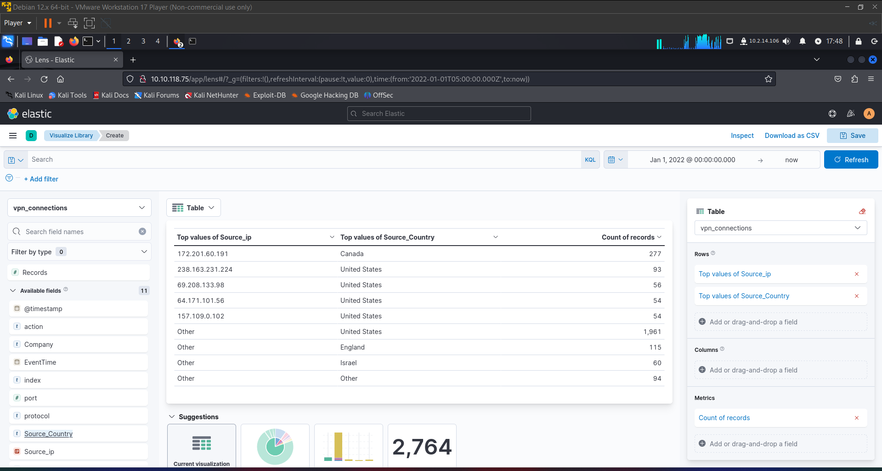

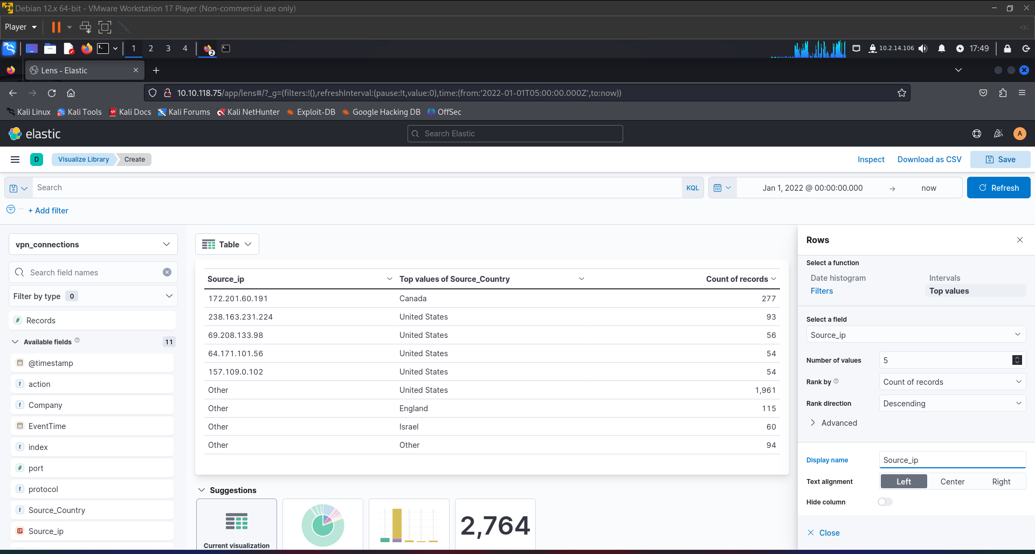

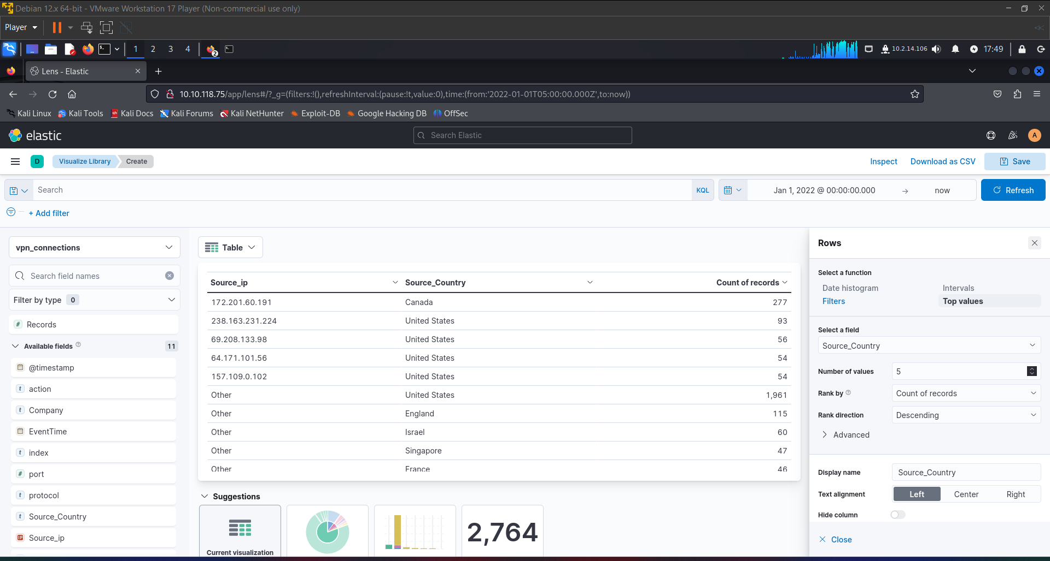

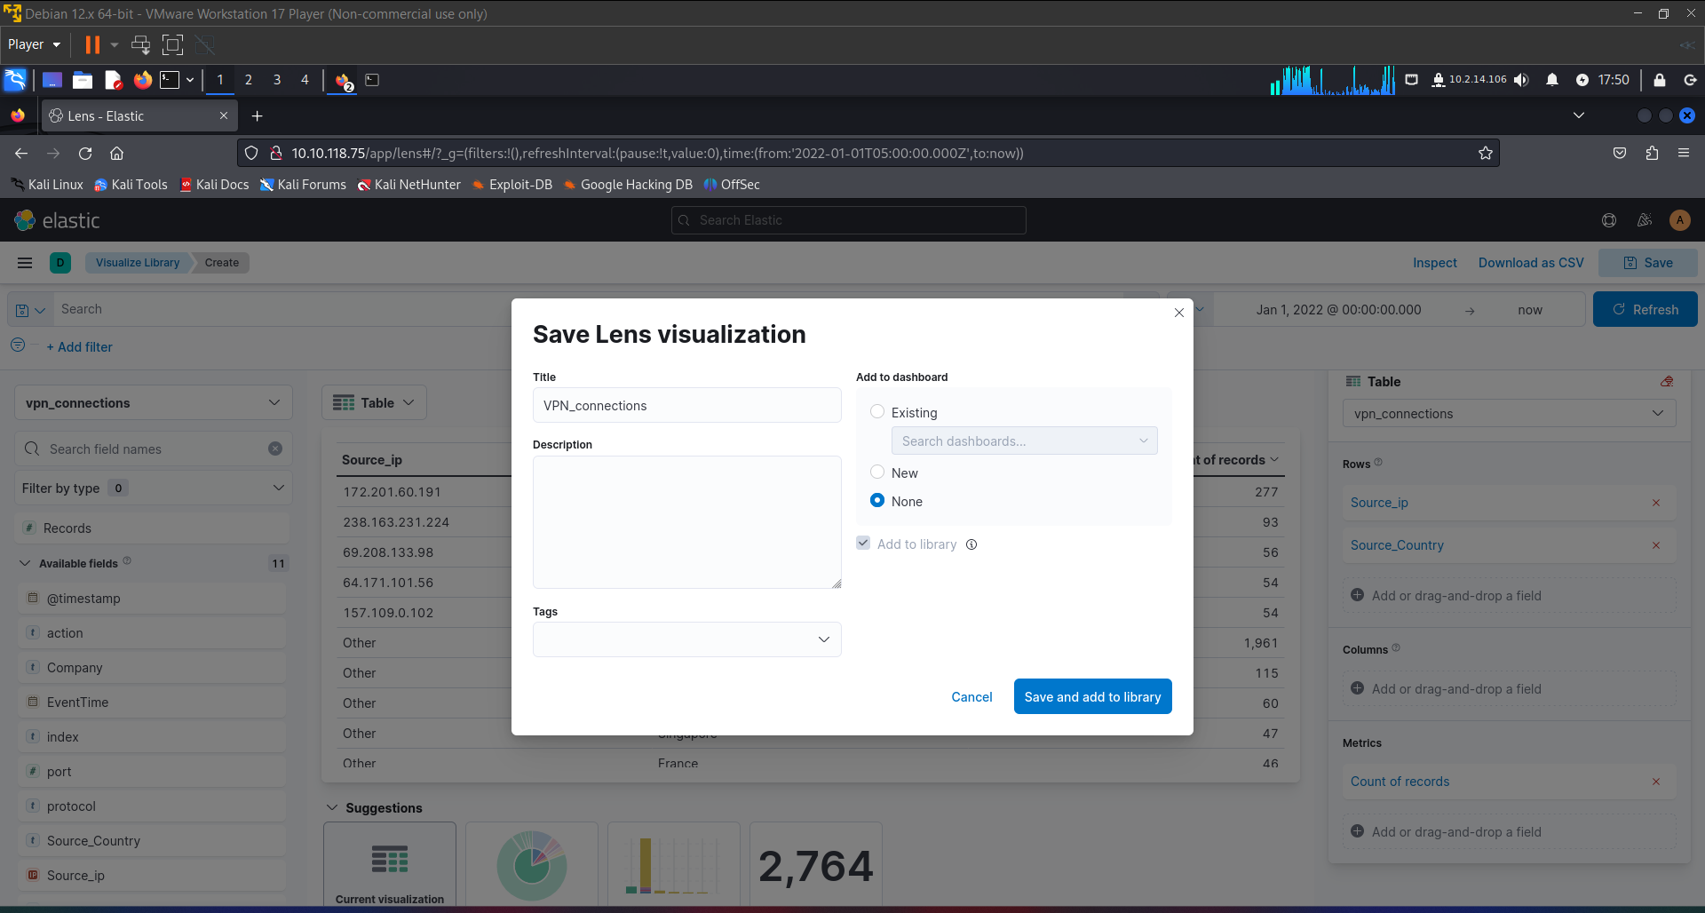

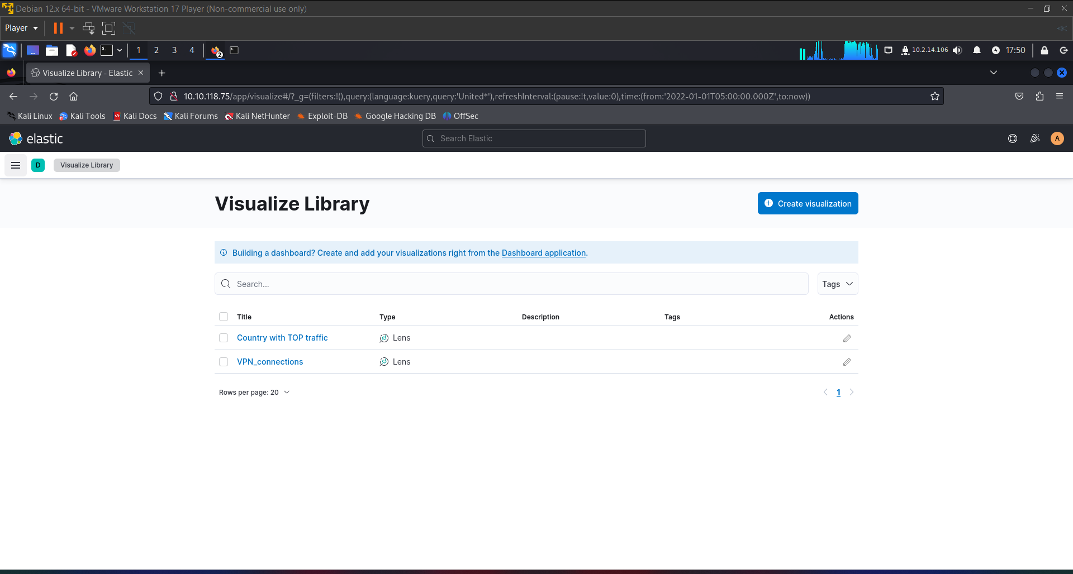

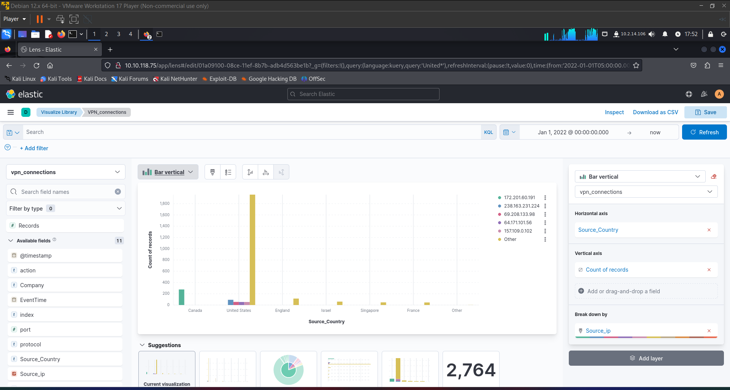

Visualization for Failed Connections

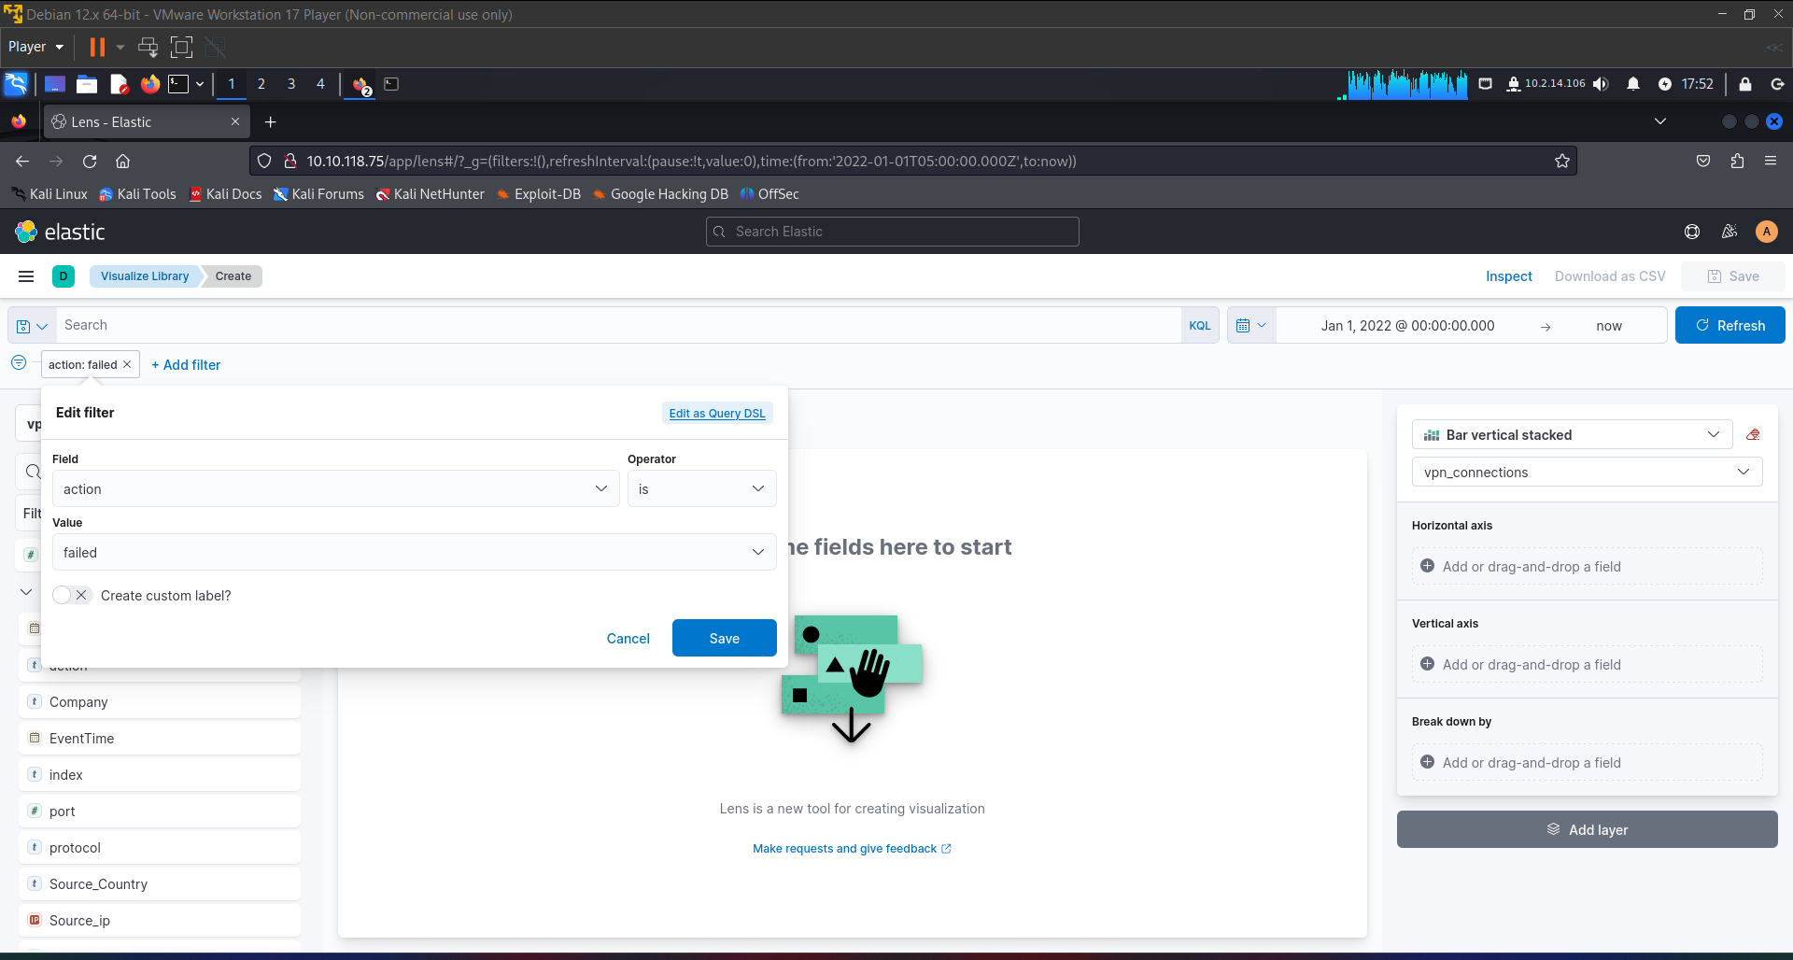

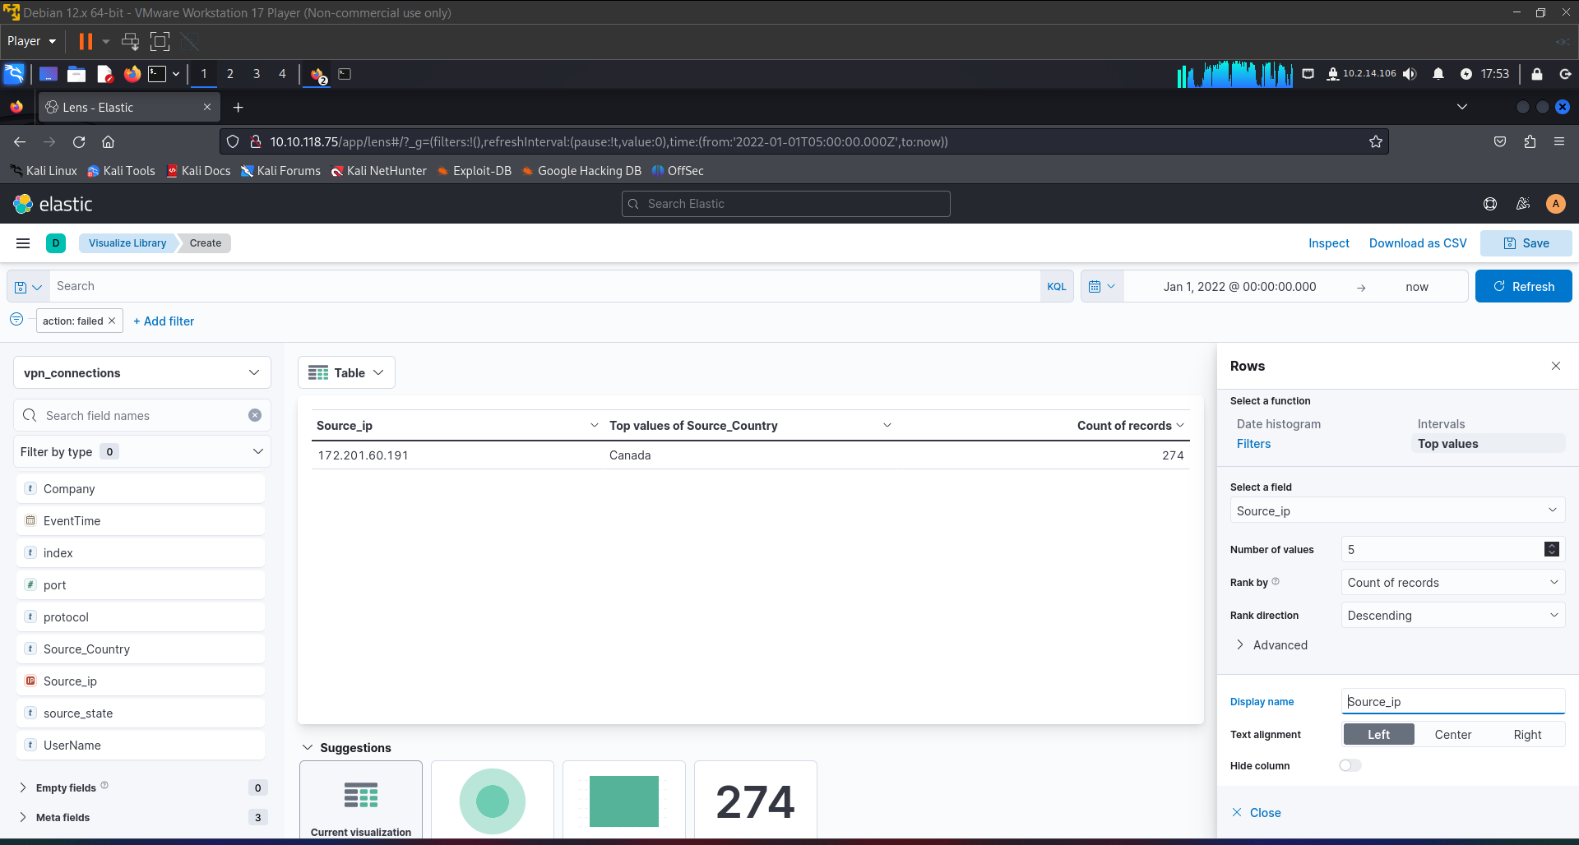

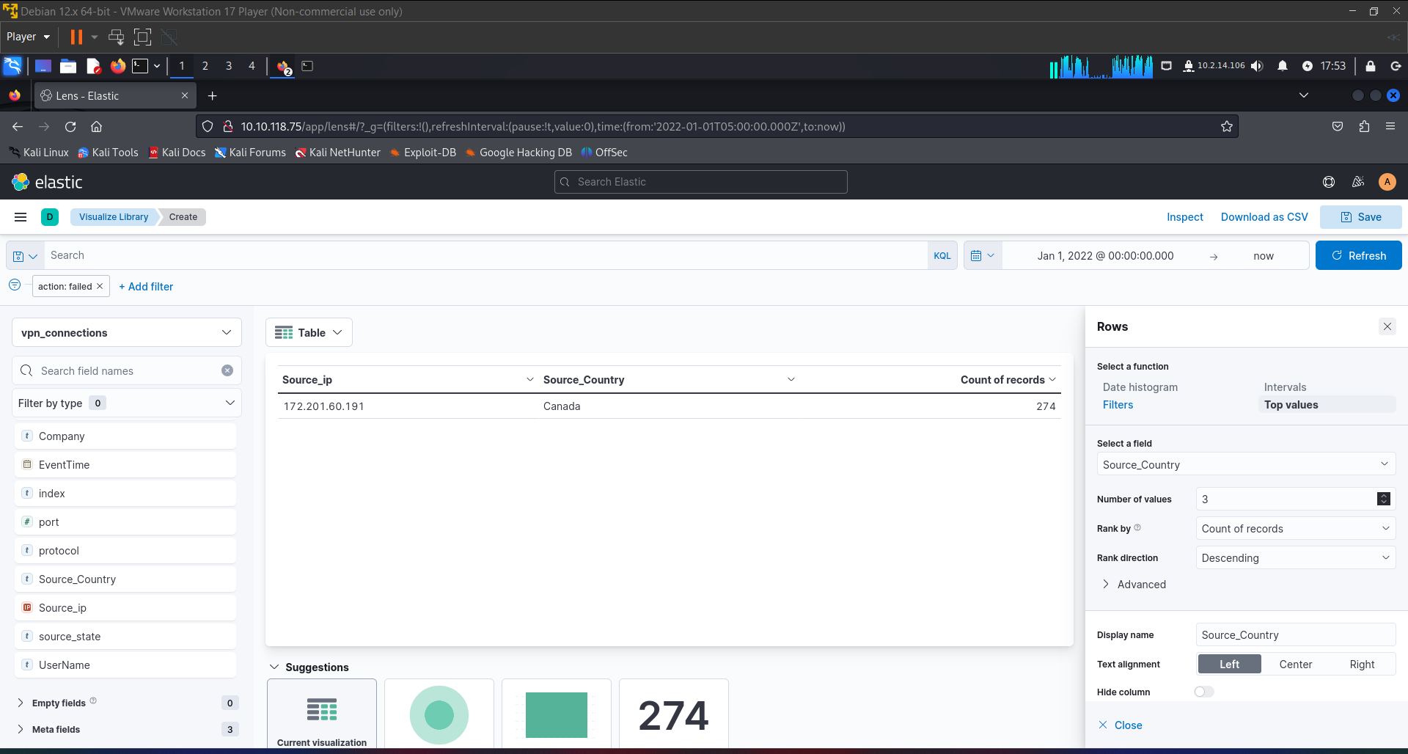

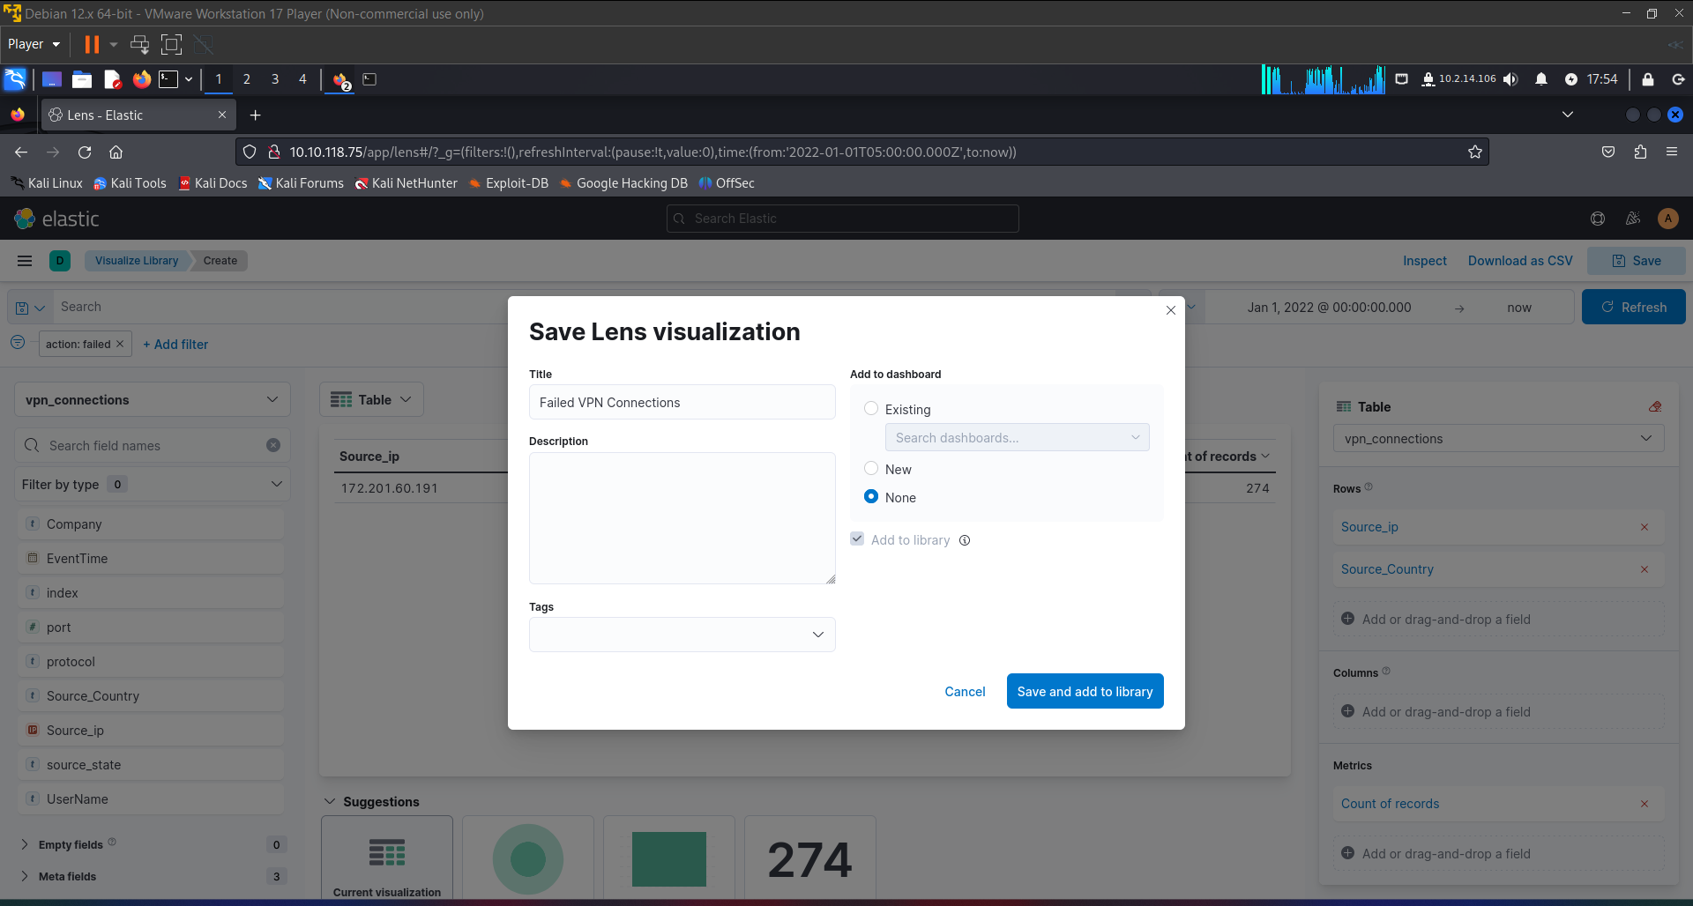

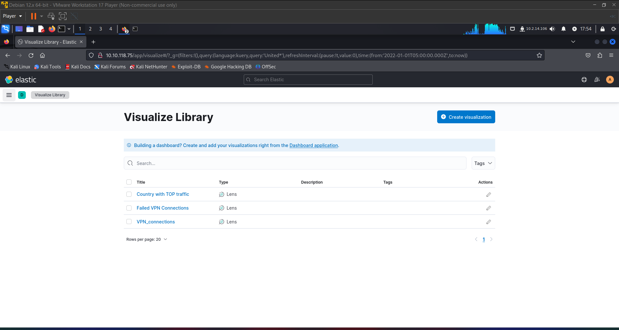

**Creating Custom Dashboard**

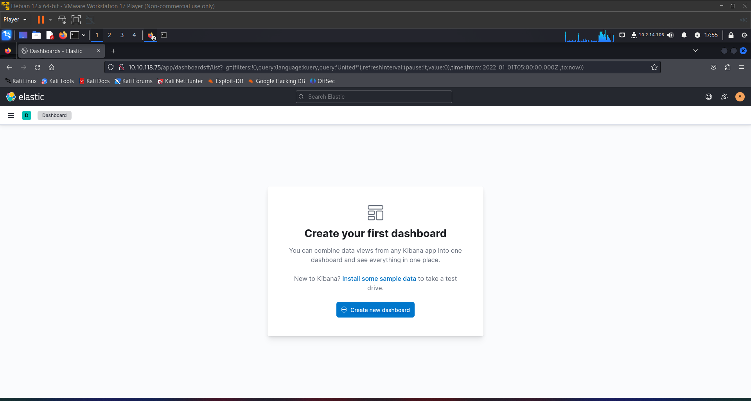

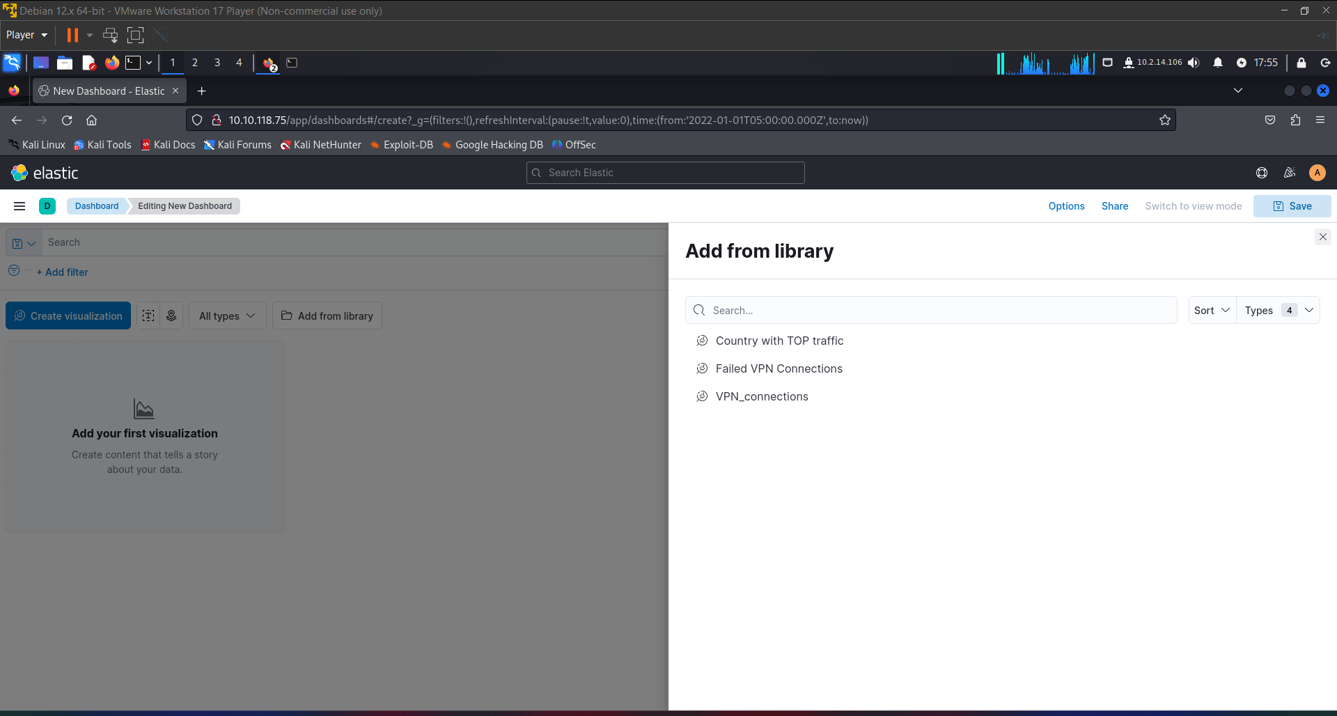

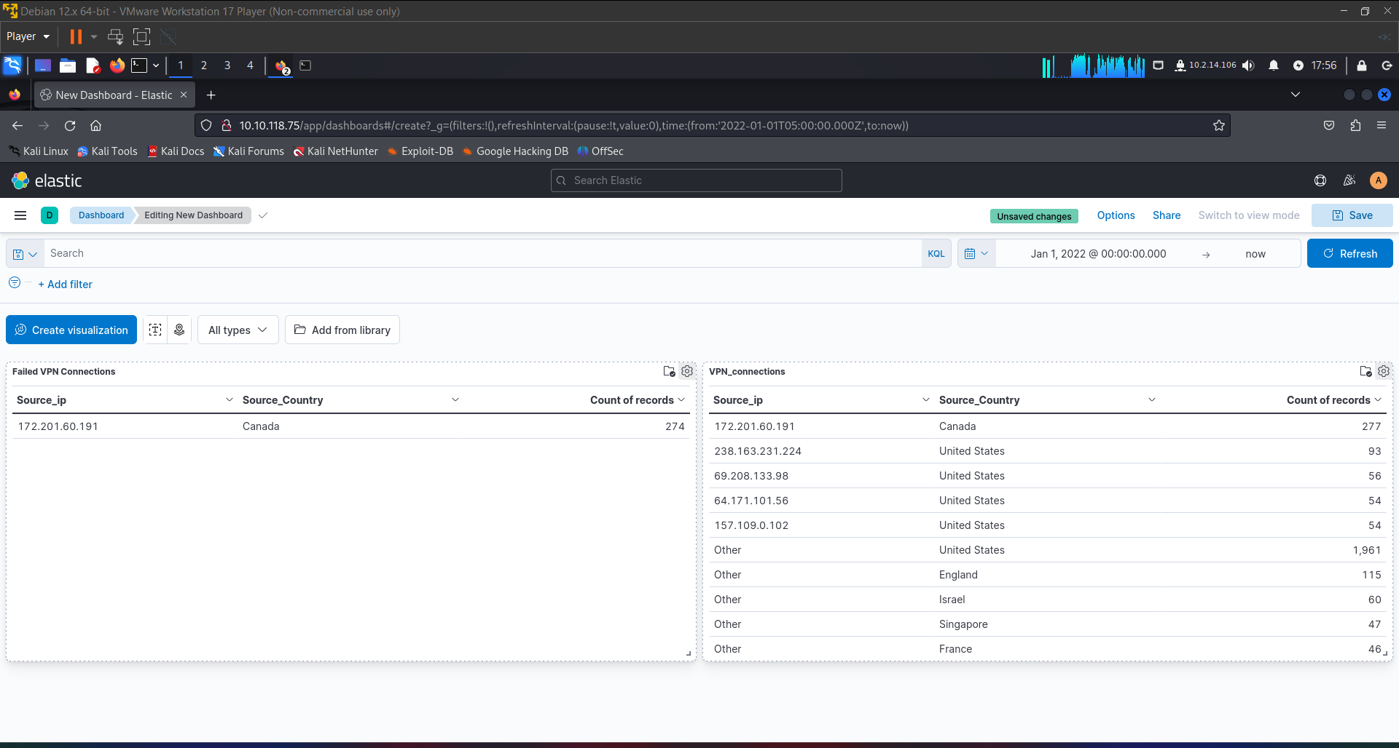

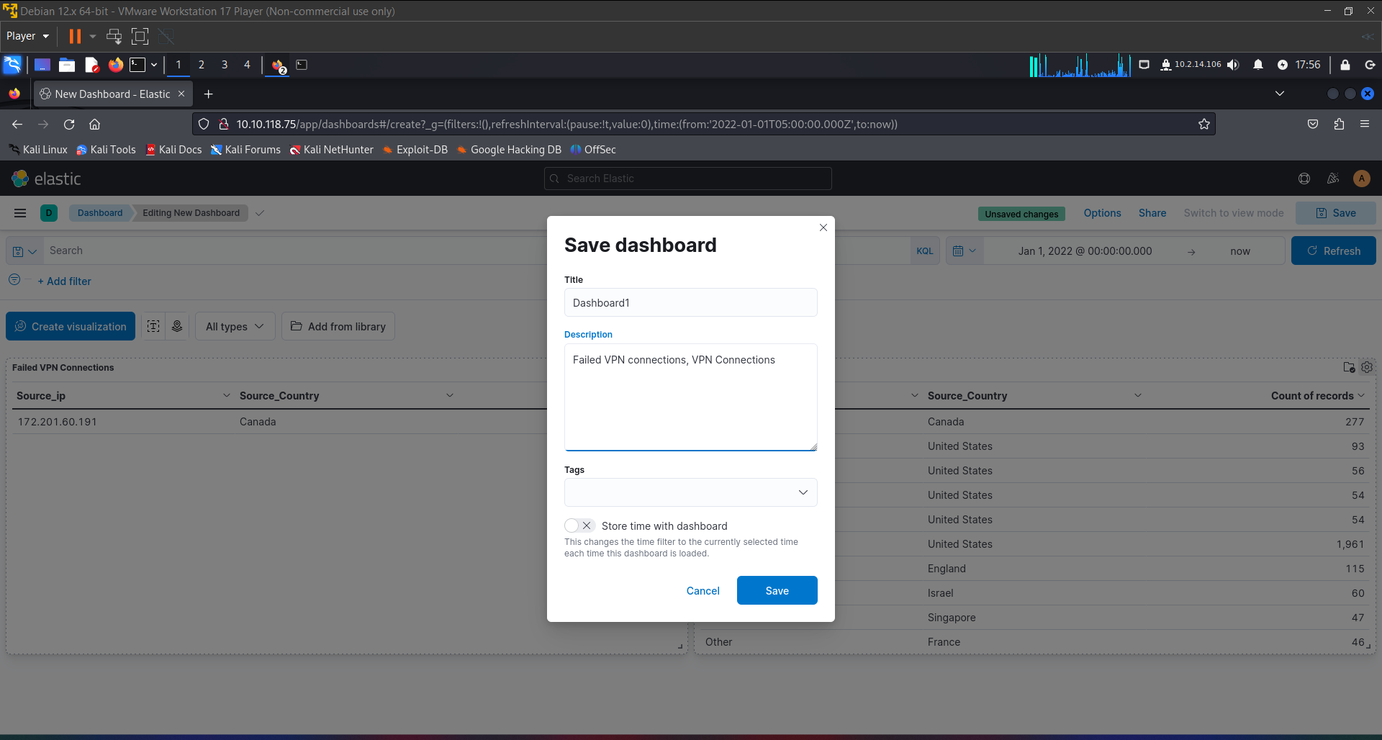

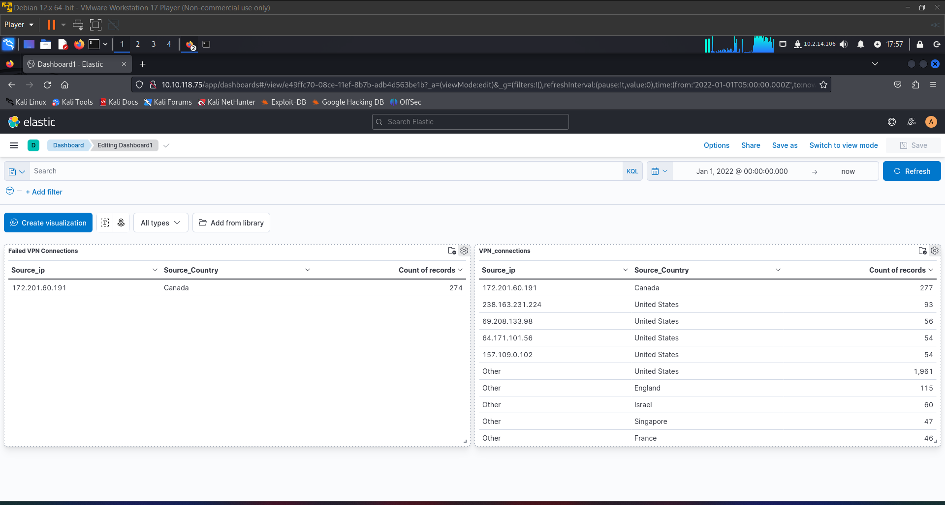

ItsyBitsy

Put your ELK knowledge together and investigate an incident.

During normal SOC monitoring, Analyst **John**observed an alert on an IDS solution indicating a potential C2 communication from a user **Browne**from the HR department. A suspicious file was accessed containing a malicious pattern THM:{ ________ }. A week-long HTTP connection logs have been pulled to investigate. Due to limited resources, only the connection logs could be pulled out and are ingested into the **connection_logs** index in Kibana.

Our task in this room will be to examine the network connection logs of this user, find the link and the content of the file, and answer the questions.

Answer the questions below

How many events were returned for the month of March 2022?

Top of Form

Correct Answer 1482

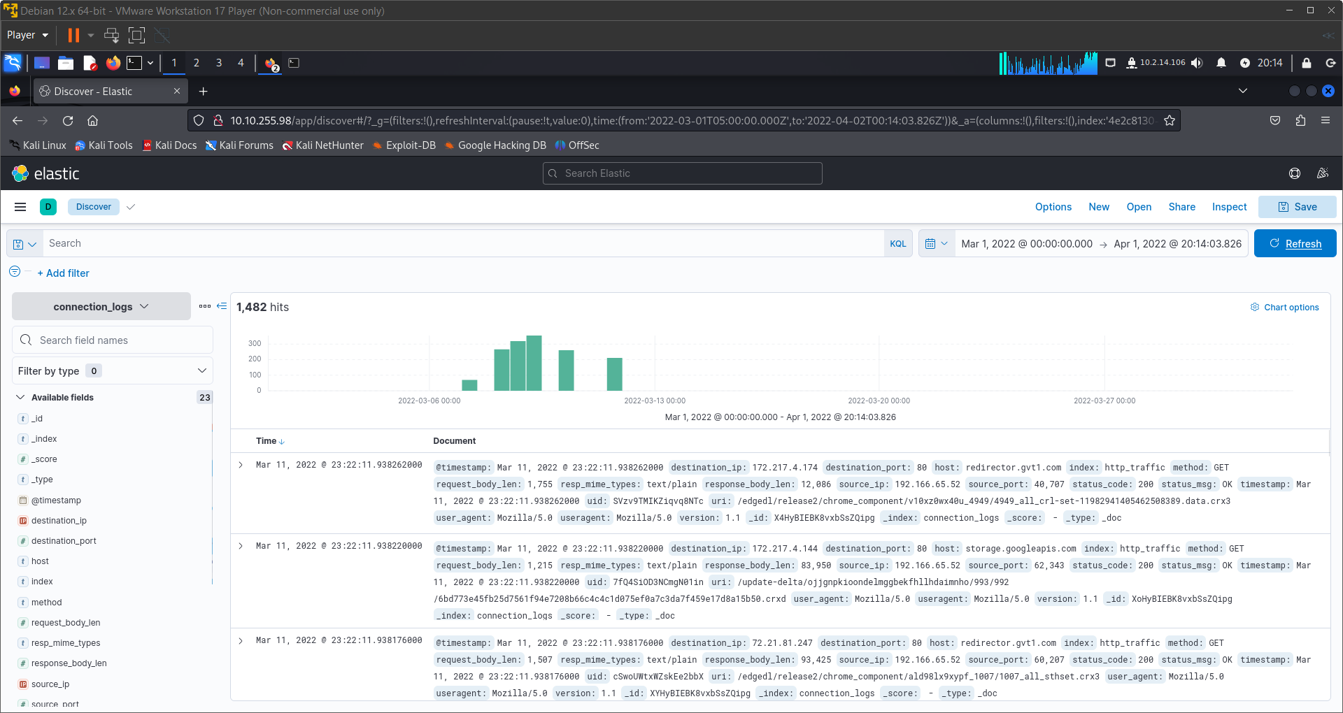

Bottom of Form

What is the IP associated with the suspected user in the logs?

Top of Form

Correct Answer 192.166.65.54

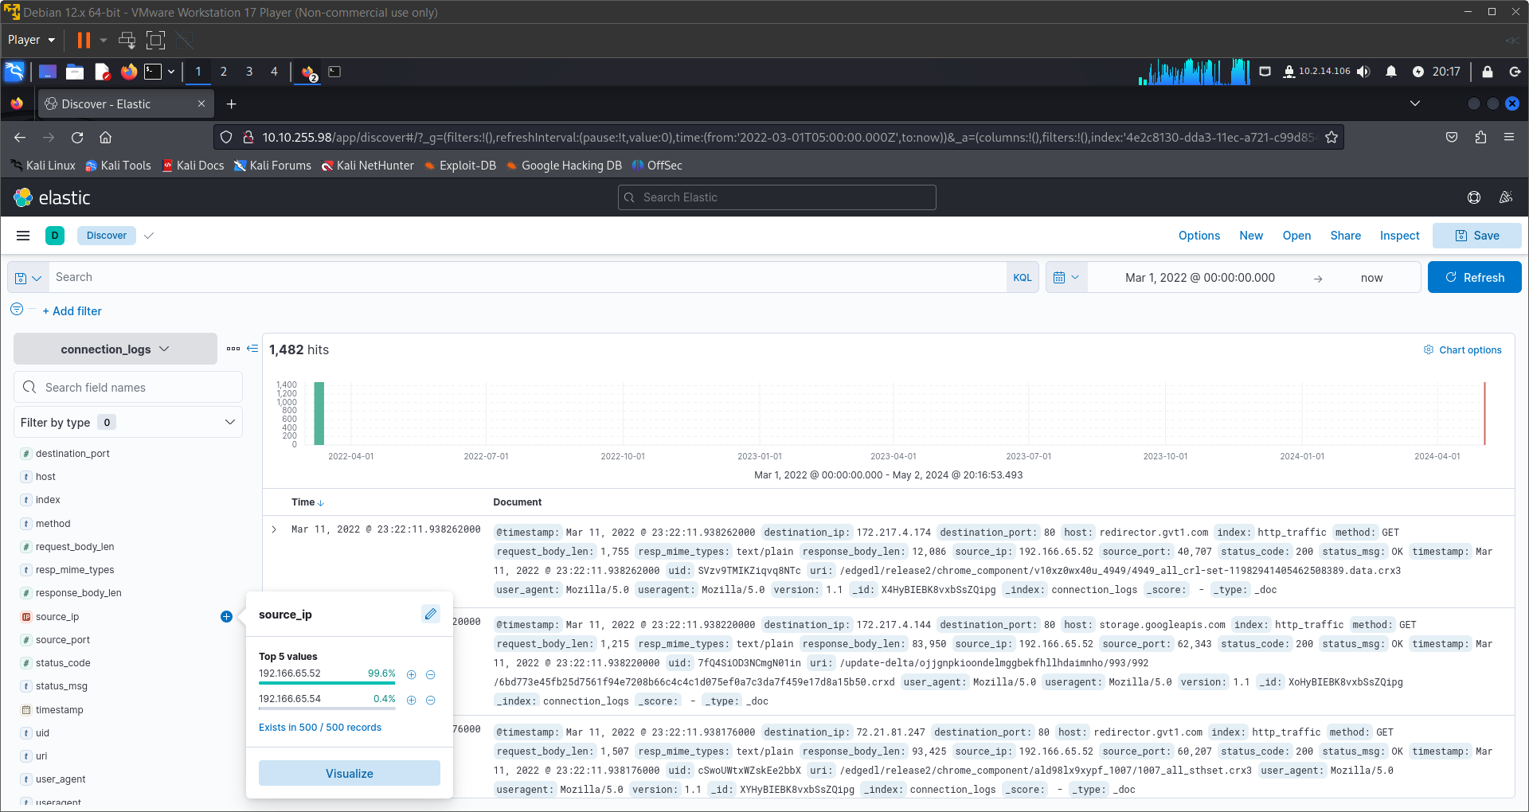

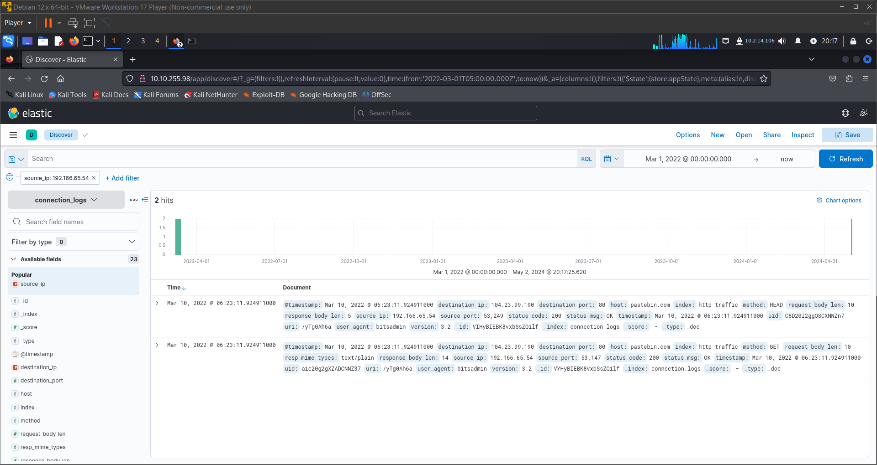

Bottom of Form

The user’s machine used a legit windows binary to download a file from the C2 server. What is the name of the binary?

Top of Form

Correct Answer bitsadmin

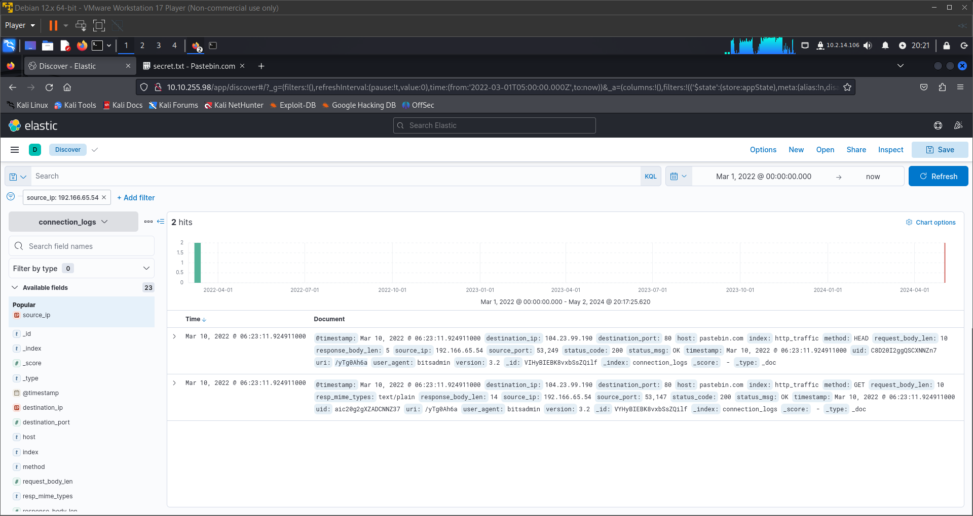

Bottom of Form

The infected machine connected with a famous filesharing site in this period, which also acts as a C2 server used by the malware authors to communicate. What is the name of the filesharing site?

Top of Form

Correct Answer pastebin.com

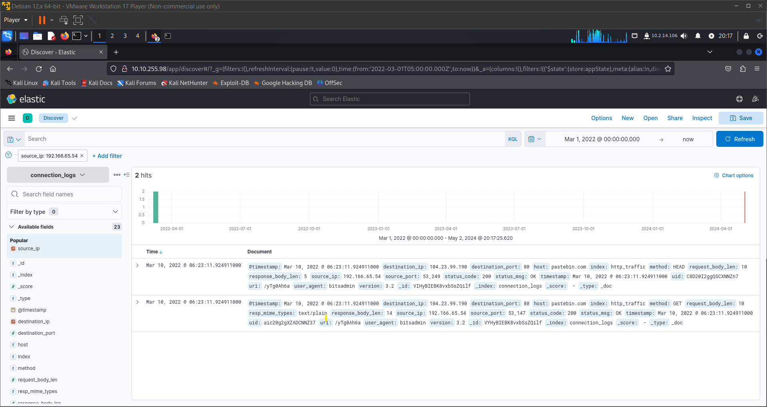

Bottom of Form

What is the full URL of the C2 to which the infected host is connected?

Top of Form

Correct Answer pastebin.com/yTg0Ah6a



Bottom of Form

A file was accessed on the filesharing site. What is the name of the file accessed?

Top of Form

Correct Answer secret.txt

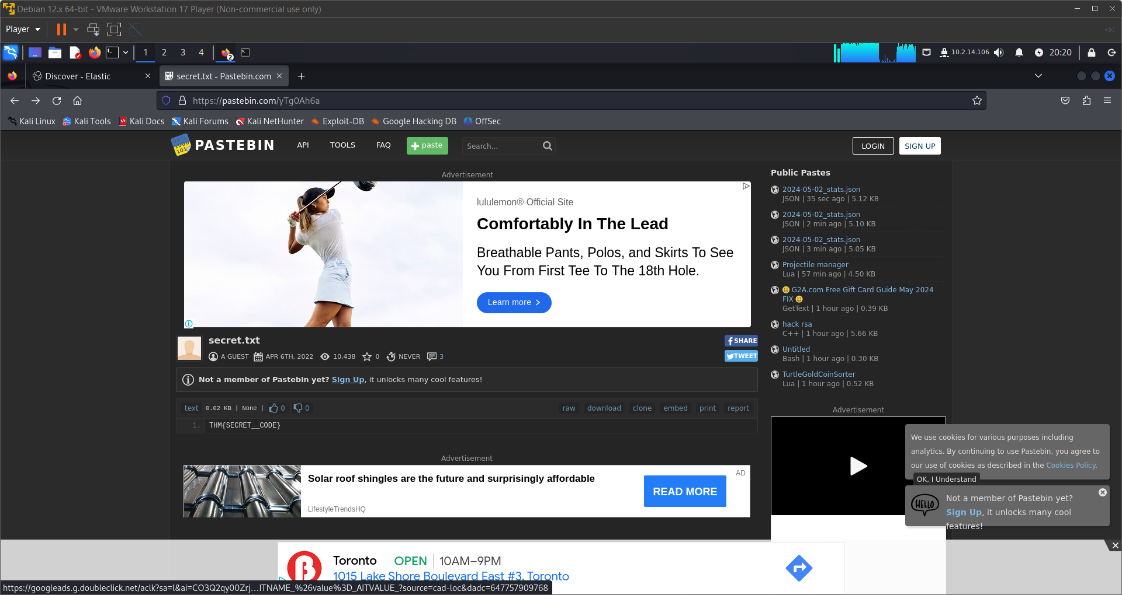

Bottom of Form

The file contains a secret code with the format THM{_____}.

Top of Form

Correct Ans THM{SECRET__CODE}

Bottom of Form

ADVANCE ELK QUERIES

NESTED QUERIES

Take a look at the dataset below:

| **record_id** | **incident_type** | **affected_systems** | **comments** |
| --- | --- | --- | --- |
| 1 | DDoS | [{"system": "web-server"}, {"system": "database"}] | [{"author": "Alice", "text": "Mitigated DDoS attack"}, {"author": "Bob", "text": "Checked logs, found suspicious IPs"}] |
| 2 | Malware | [{"system": "web-server"}, {"system": "file-server"}] | [{"author": "Charlie", "text": "Removed malware"}, {"author": "Eve", "text": "Updated antivirus software"}] |
| 3 | Data breach | [{"system": "database"}] | [{"author": "Alice", "text": "Patched vulnerability"}, {"author": "Eve", "text": "Reset all user passwords"}] |
| 4 | Phishing | [{"system": "email-server"}] | [{"author": "Bob", "text": "Blocked phishing email"}, {"author": "Charlie", "text": "Sent warning to all users"}] |
| 5 | Insider threat | [{"system": "file-server"}, {"system": "database"}] | [{"author": "Eve", "text": "Investigating employee activity"}, {"author": "Alice", "text": "Implementing stricter access controls"}] |

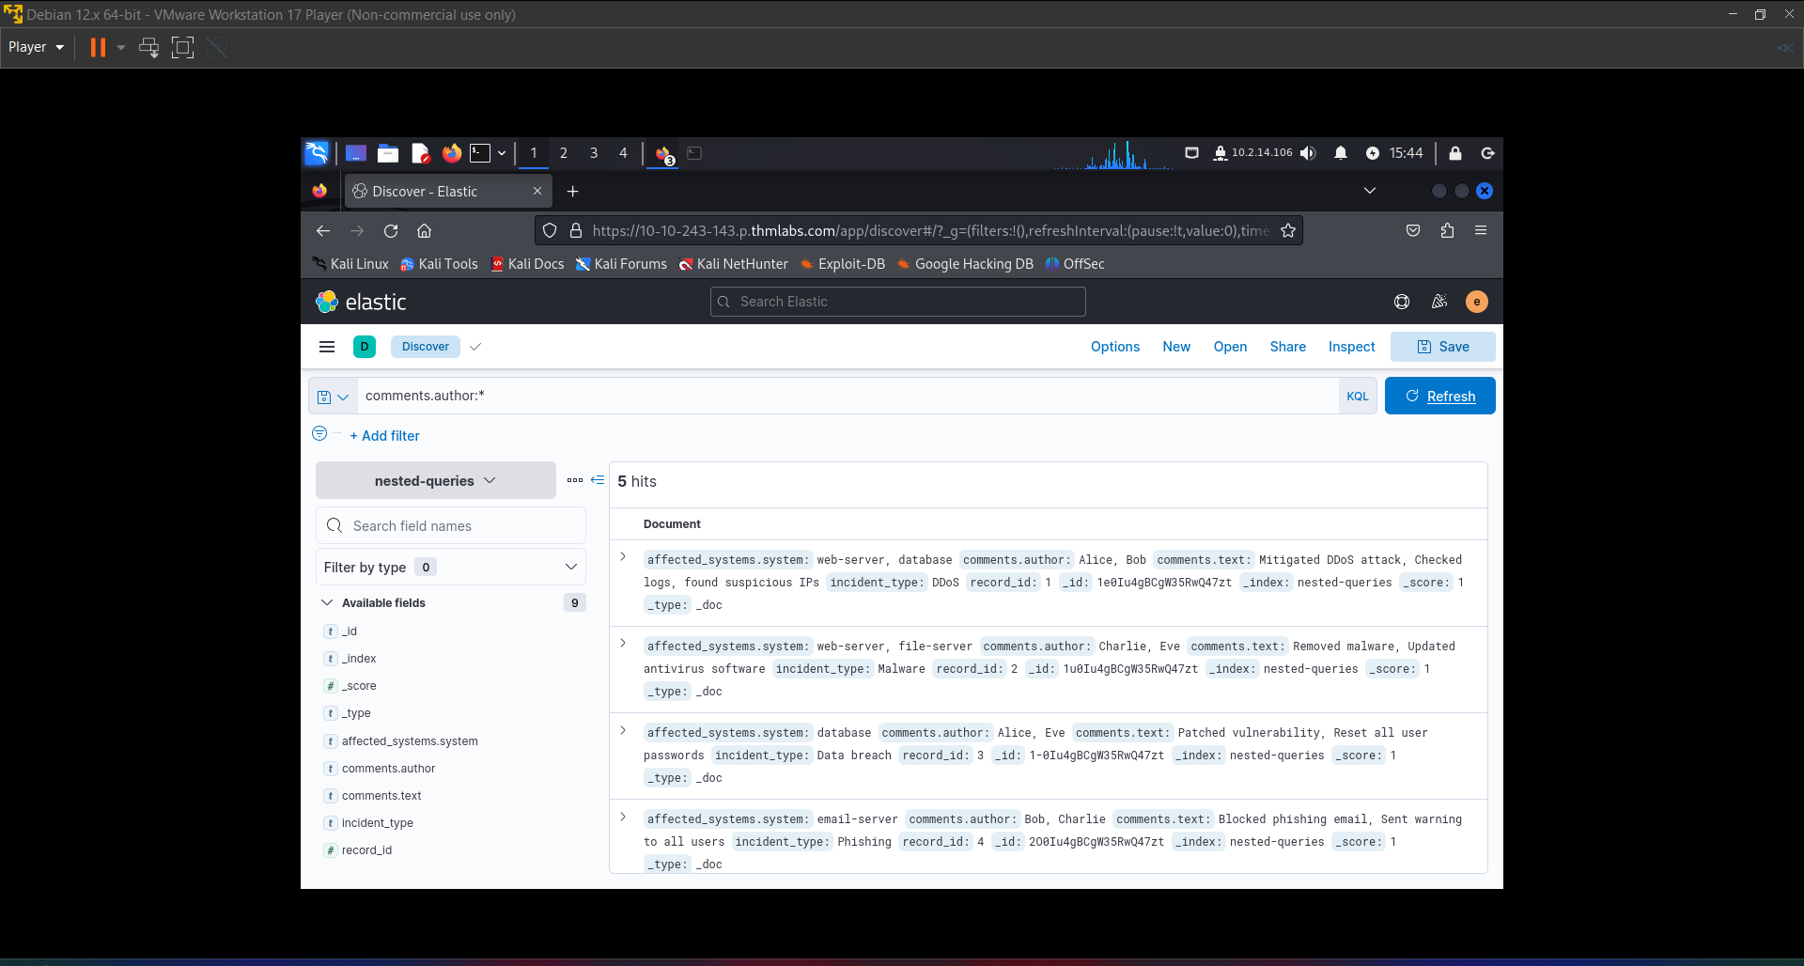

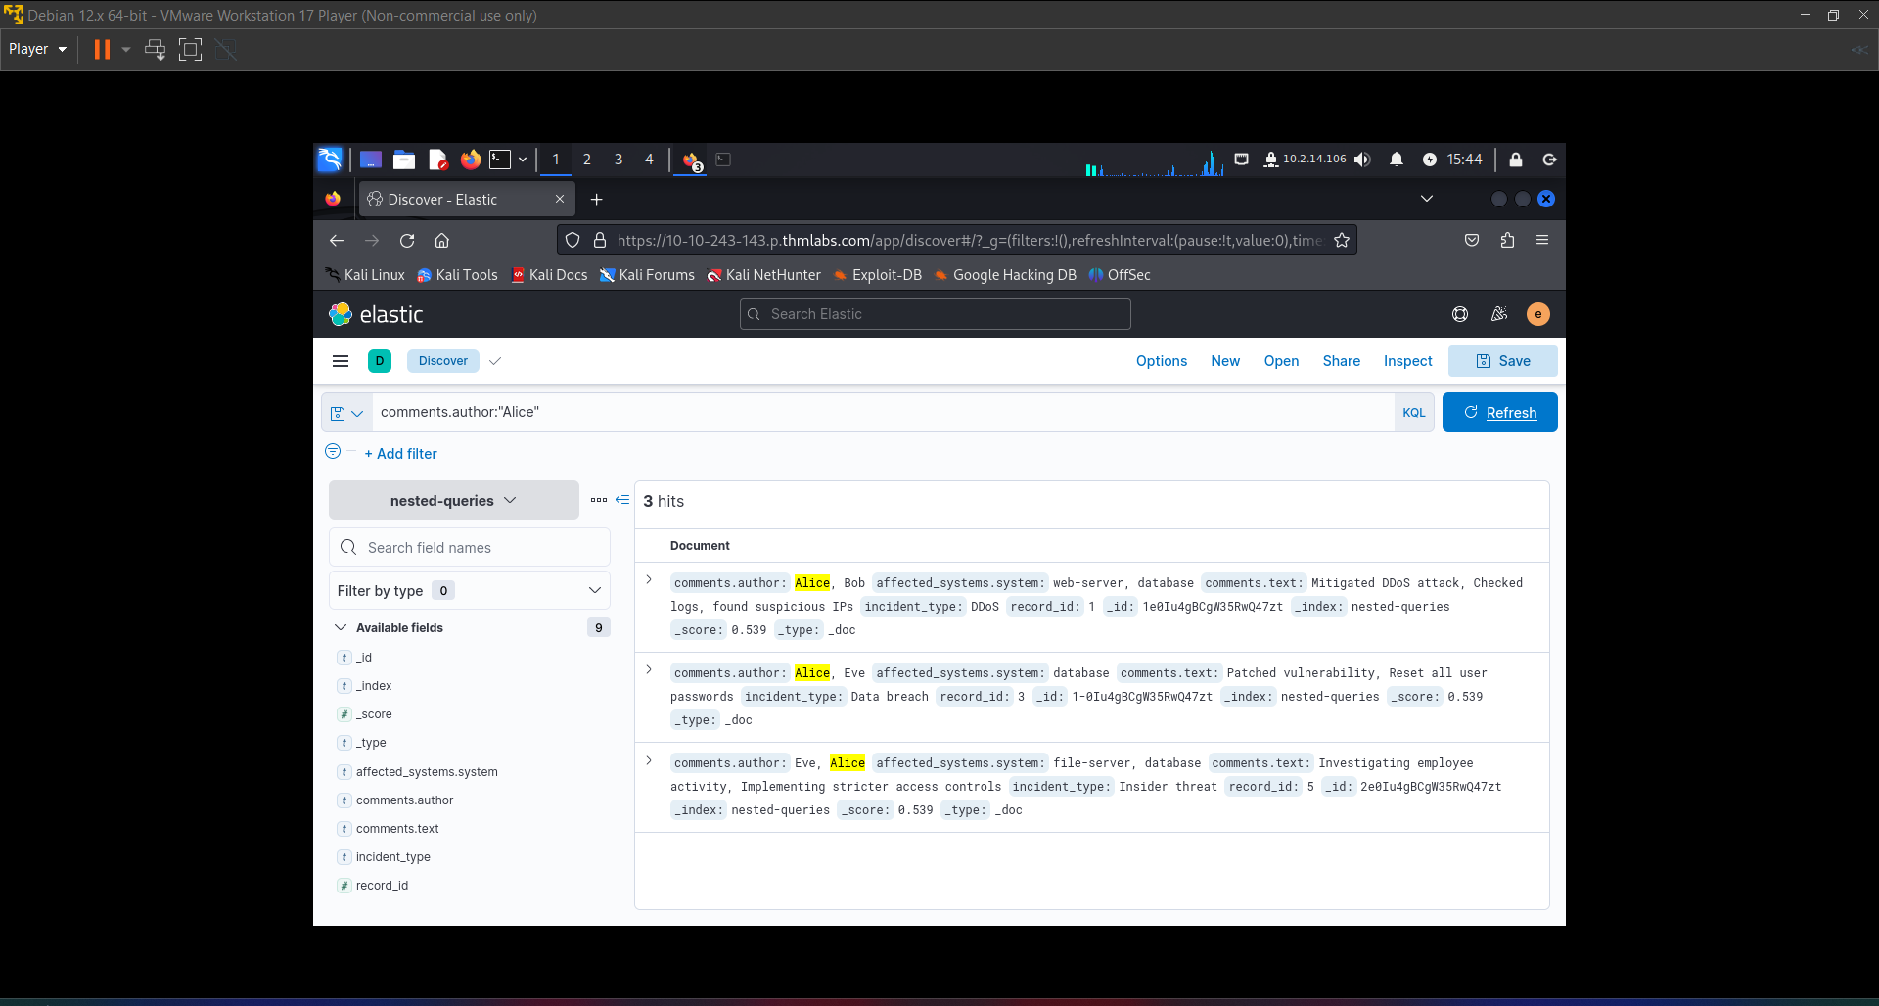

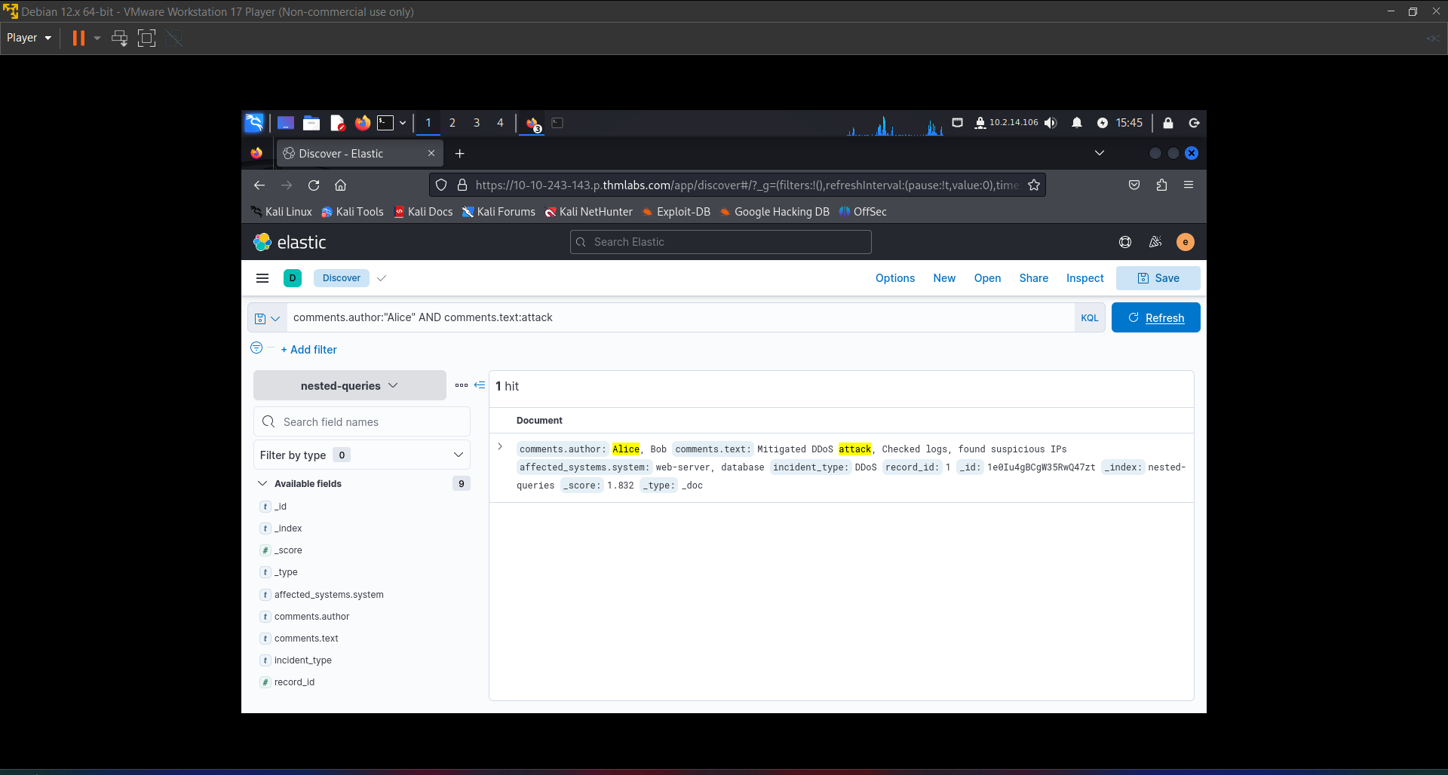

Bottom of Form

Bottom of Form

How many incidents exist where the affected file is "marketing_strategy_2023_07_23.pptx"?

Top of Form

Correct Answer 4

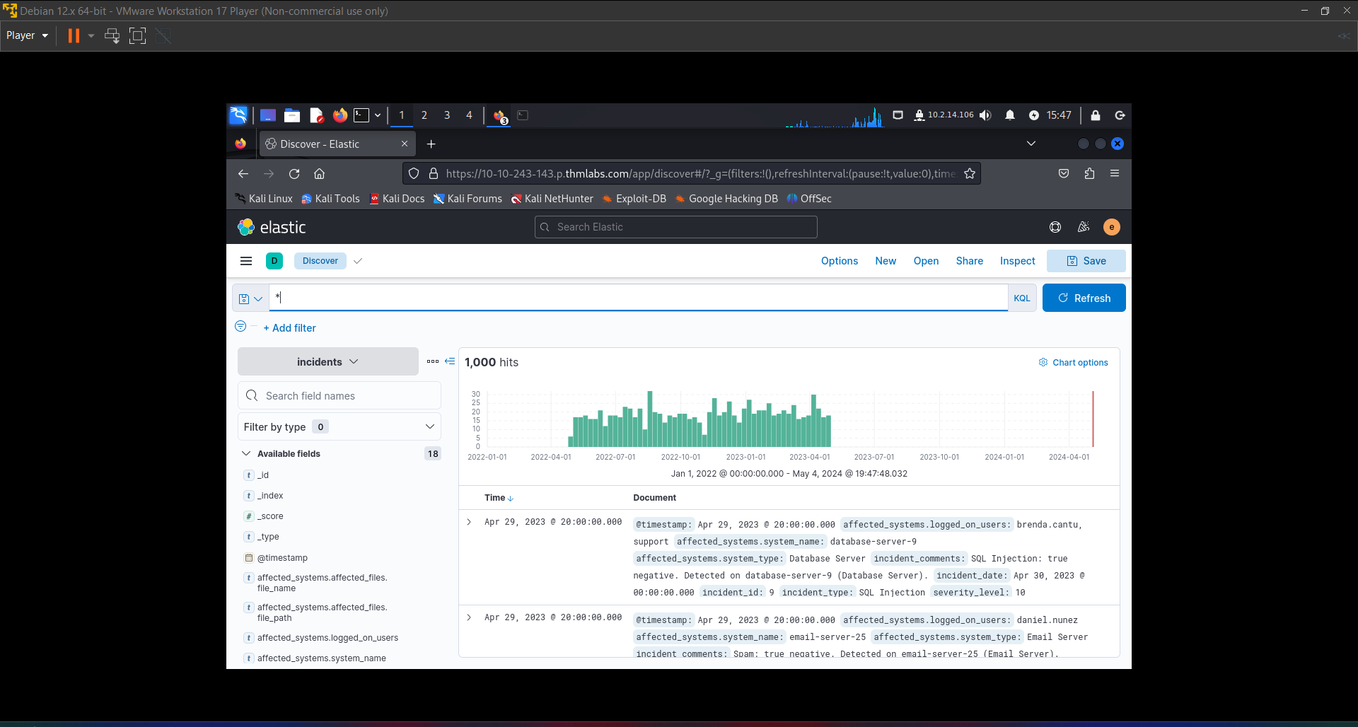

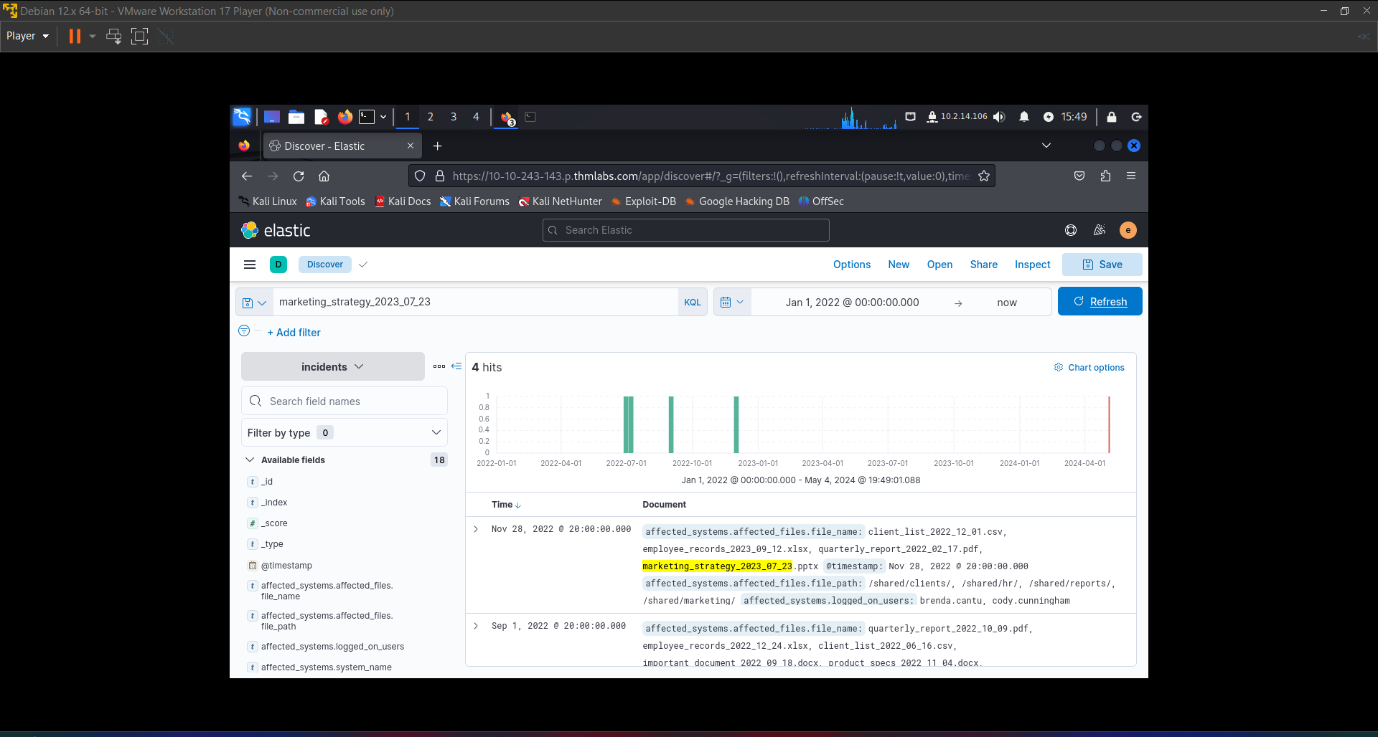

How many incidents exist where the affected files in file servers are titled "marketing_strategy"?

Top of Form

Submit 135

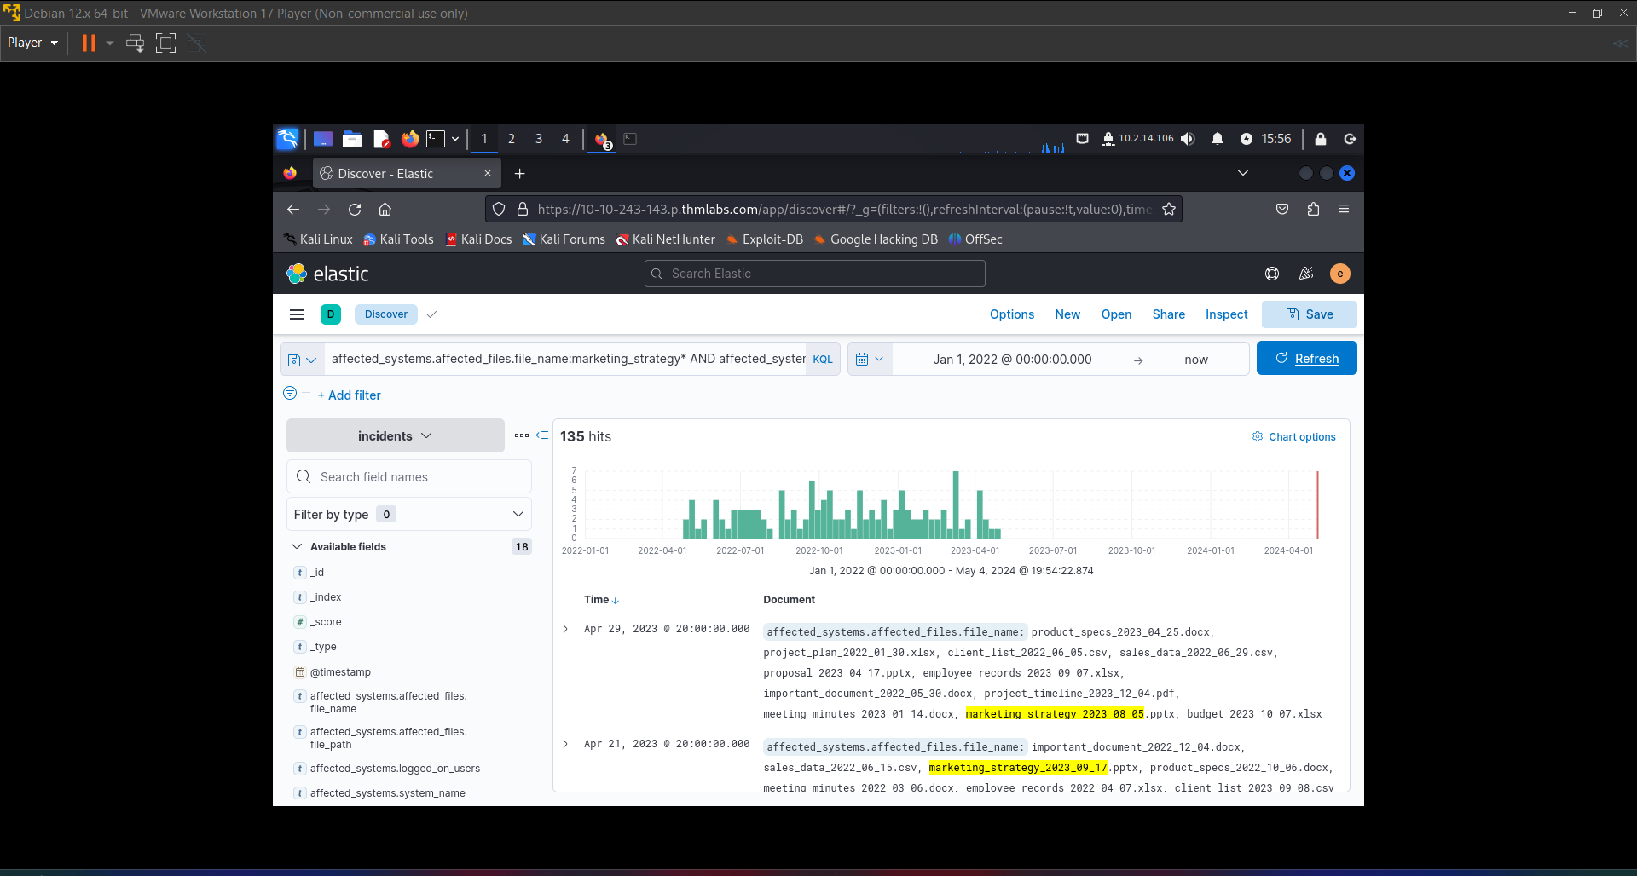

There is a true positive alert on a webserver where the admin and it users were logged on. What is the name of the webserver?

Answer: Web-server-77

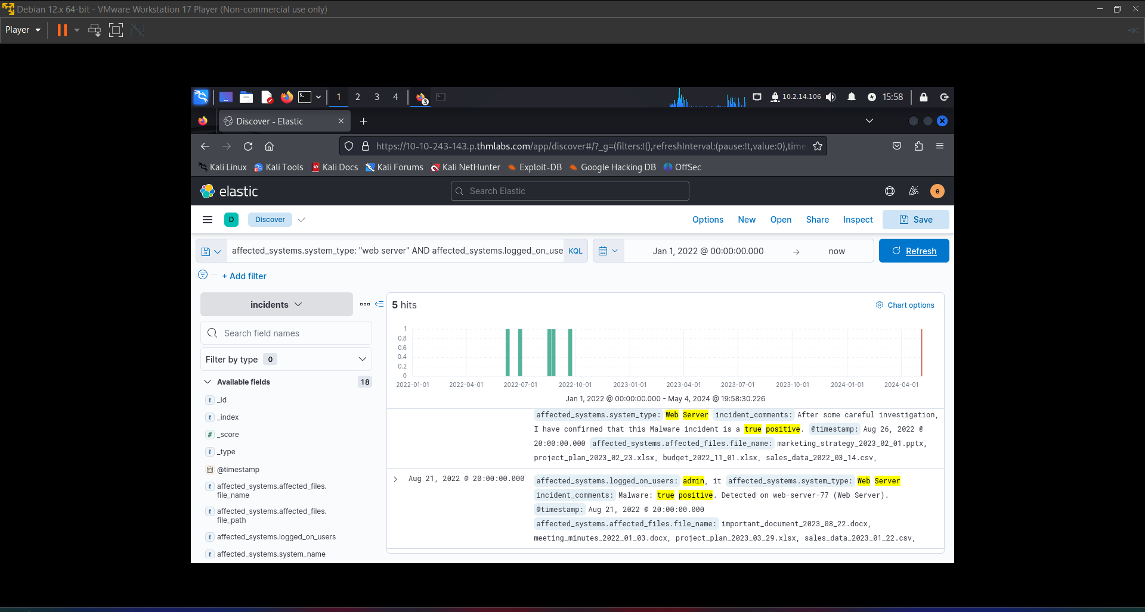

RANGES

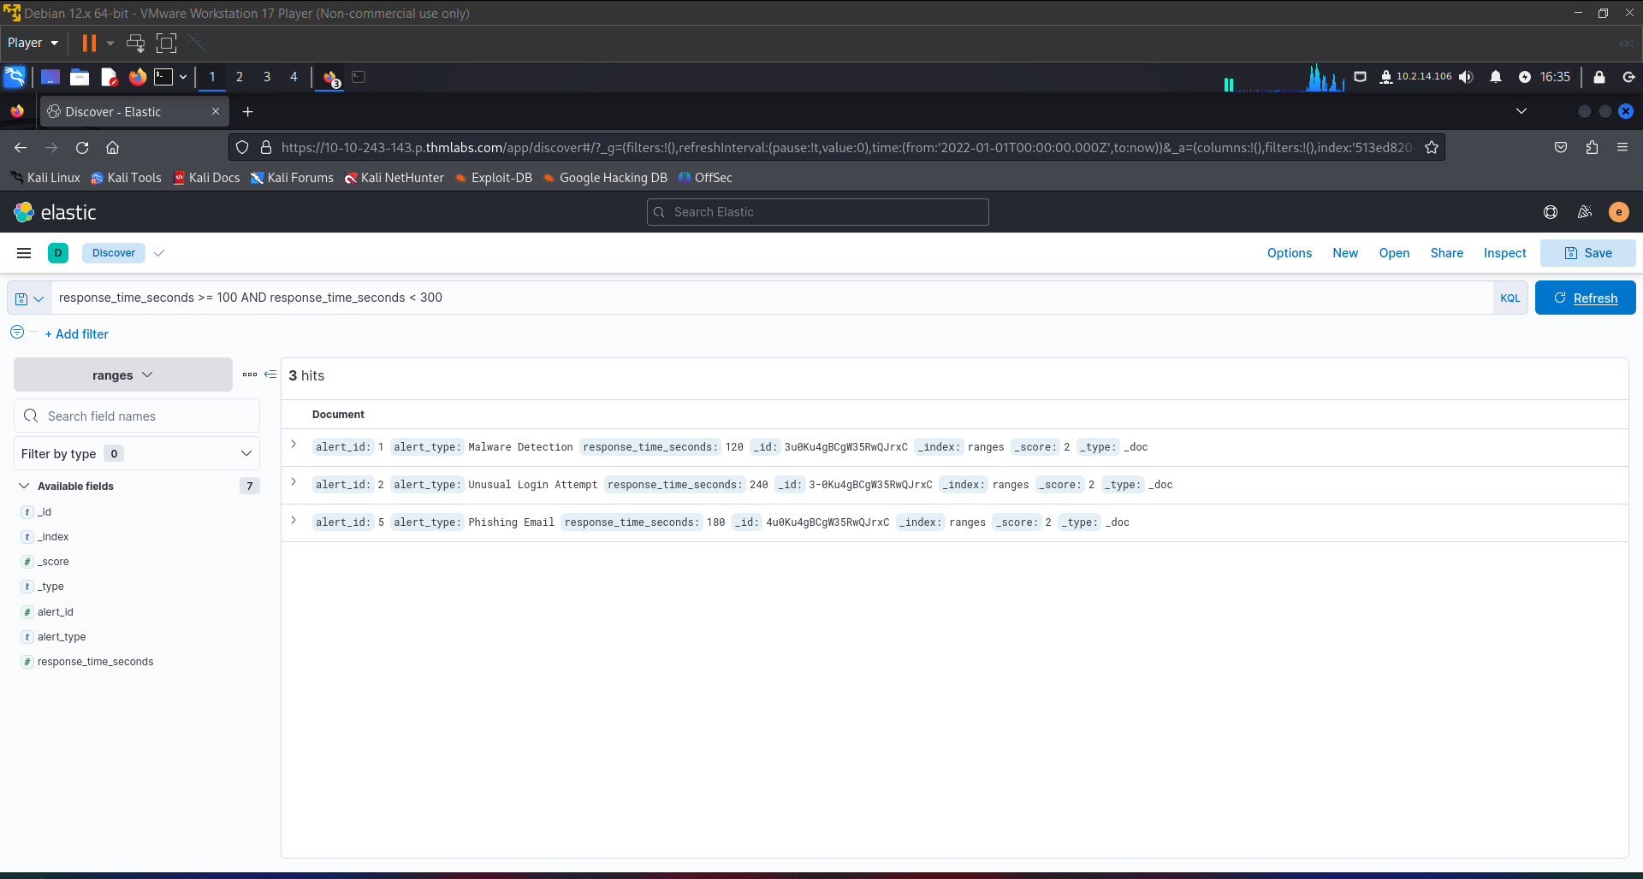

How many "Data Leak" incidents have a severity level of 9 and up?

Top of Form

Submit 52

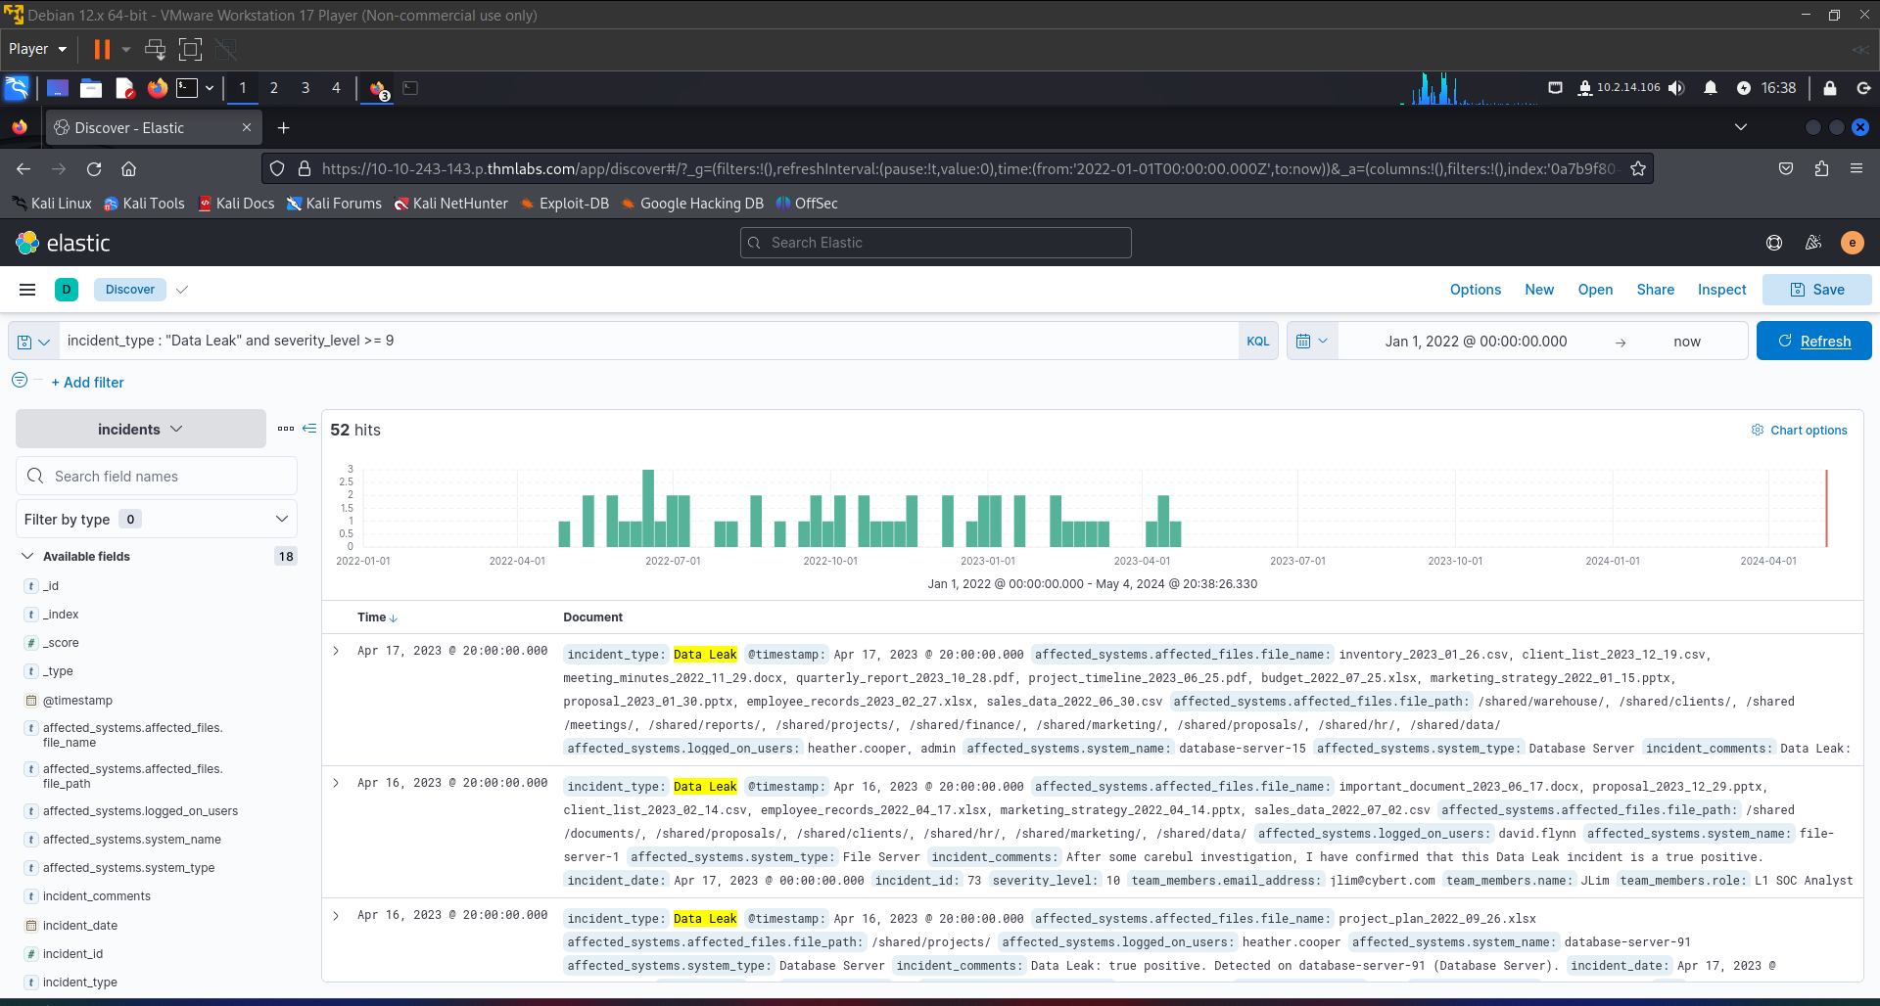

Bottom of Form

How many incidents before December 1st, 2022 has AJohnston investigated where the affected system is either an Email or Web server?

Top of Form

Submit 63

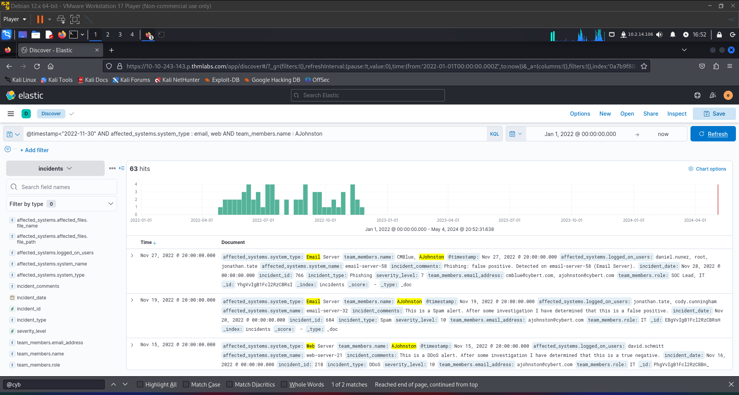

Bottom of Form

From the incident IDs 1 to 500, what is the email address of the SOC Analyst that left a comment on an incident that the data leak on file-server-65 is a false positive?

Answer: [jlim@cybert.com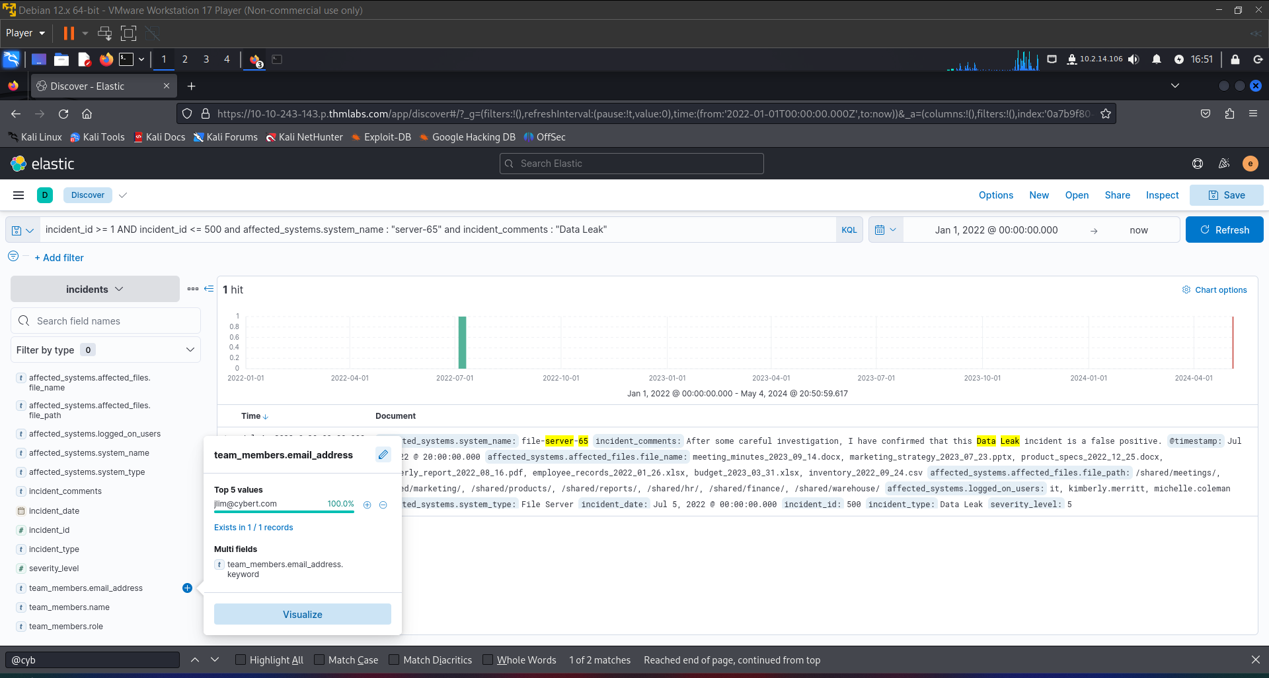](mailto:jlim@cybert.com)

FUZZY SEARCHES

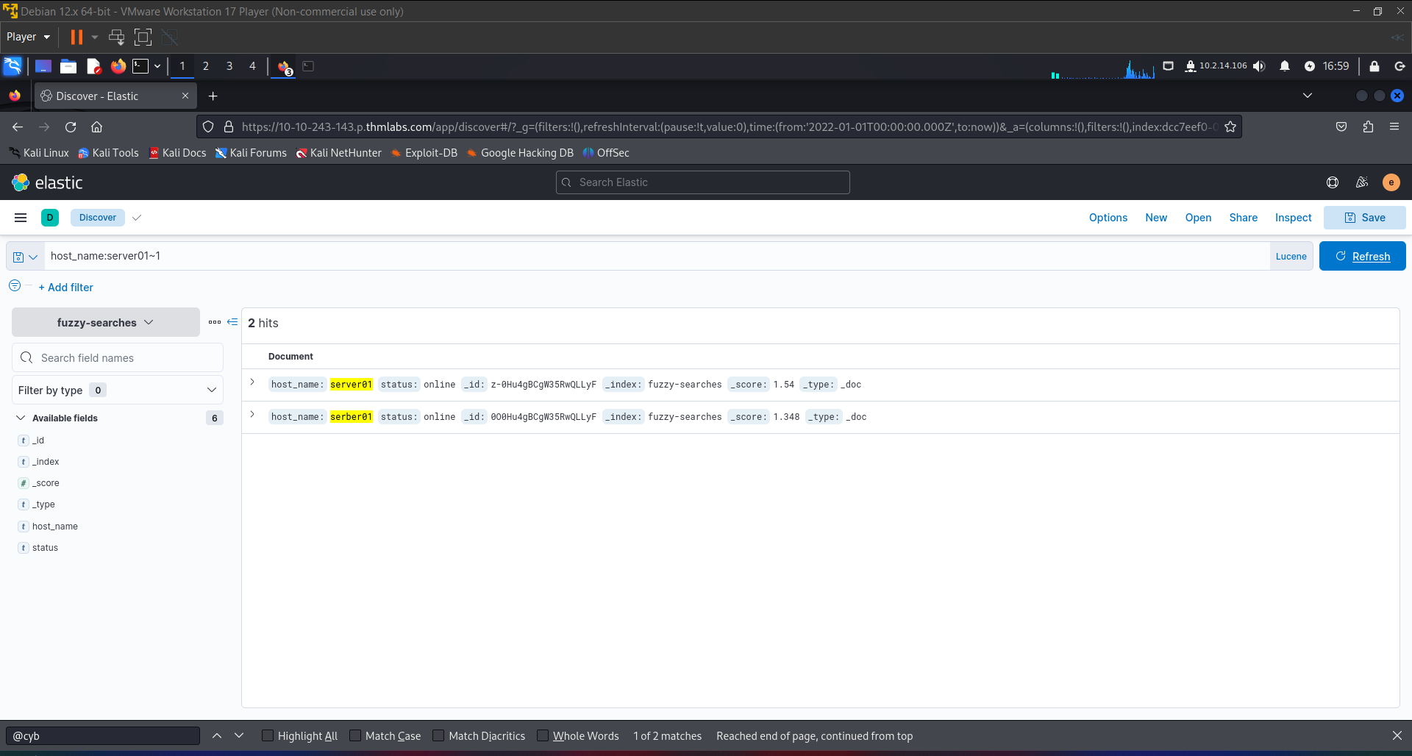

**host_name:workstation01~1**

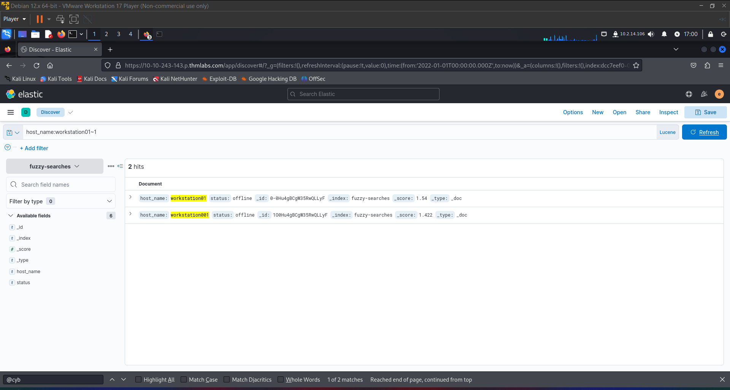

Including the misspellings, how many incidents has JLim handled where he misspelt the word “true”?  
110

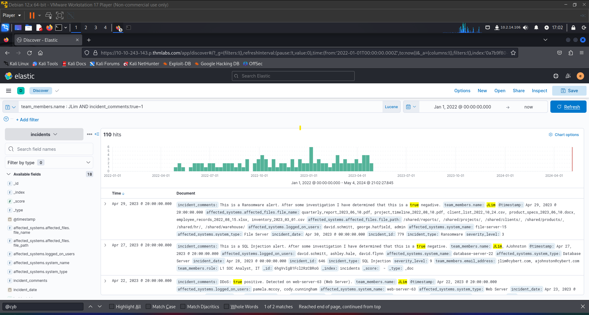

How many incidents has JLim handled where he misspelt the word “negative”?  
4(119-115)

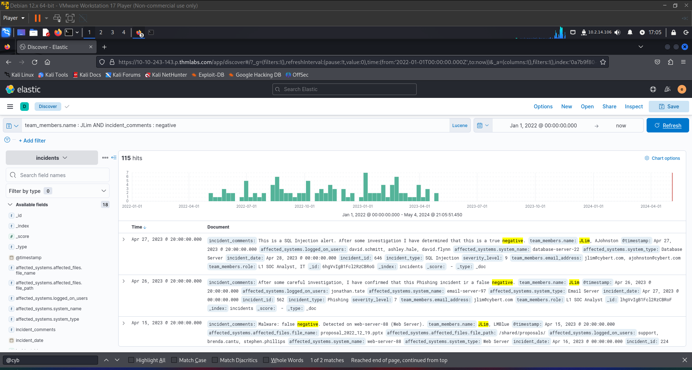

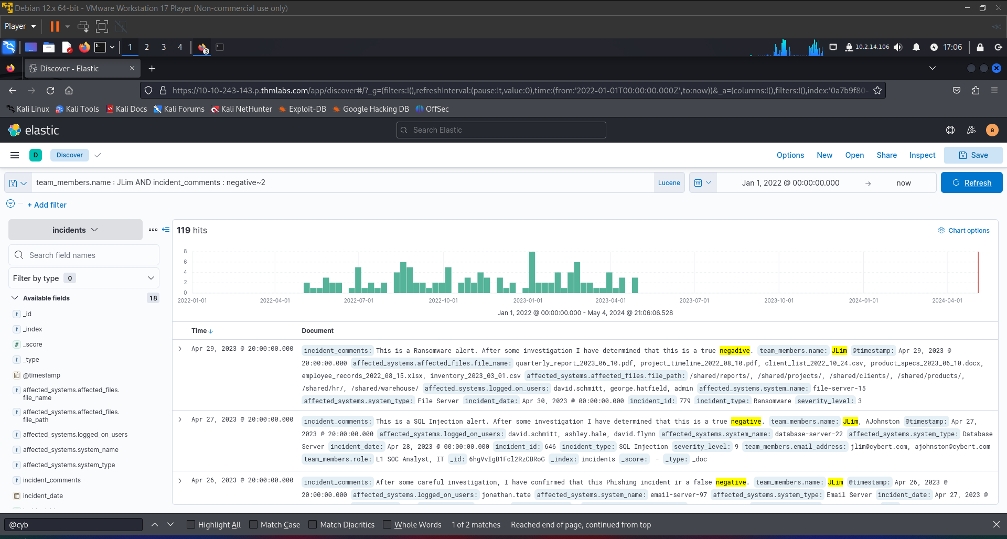

PROXIMITY SEARCHES  
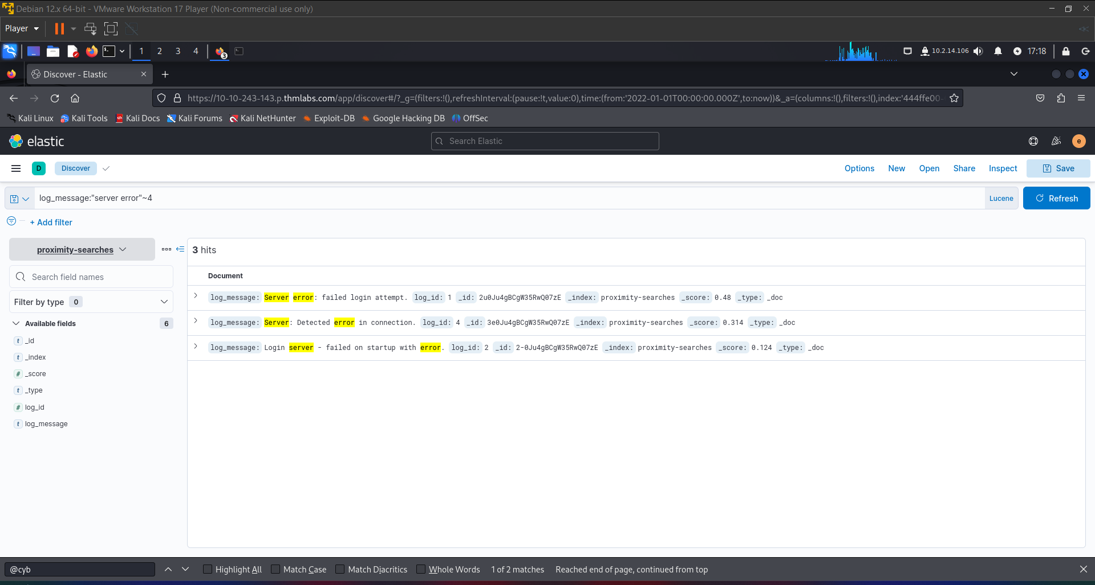

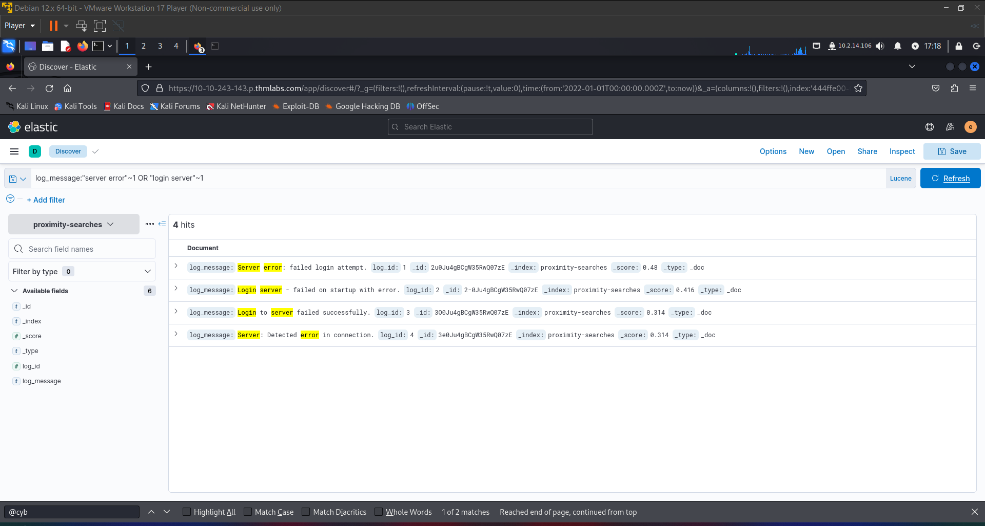

How many incidents are there when you want to look for the words “data leak” and “true negative” in the comments that are at least 3 words in between them?  
33

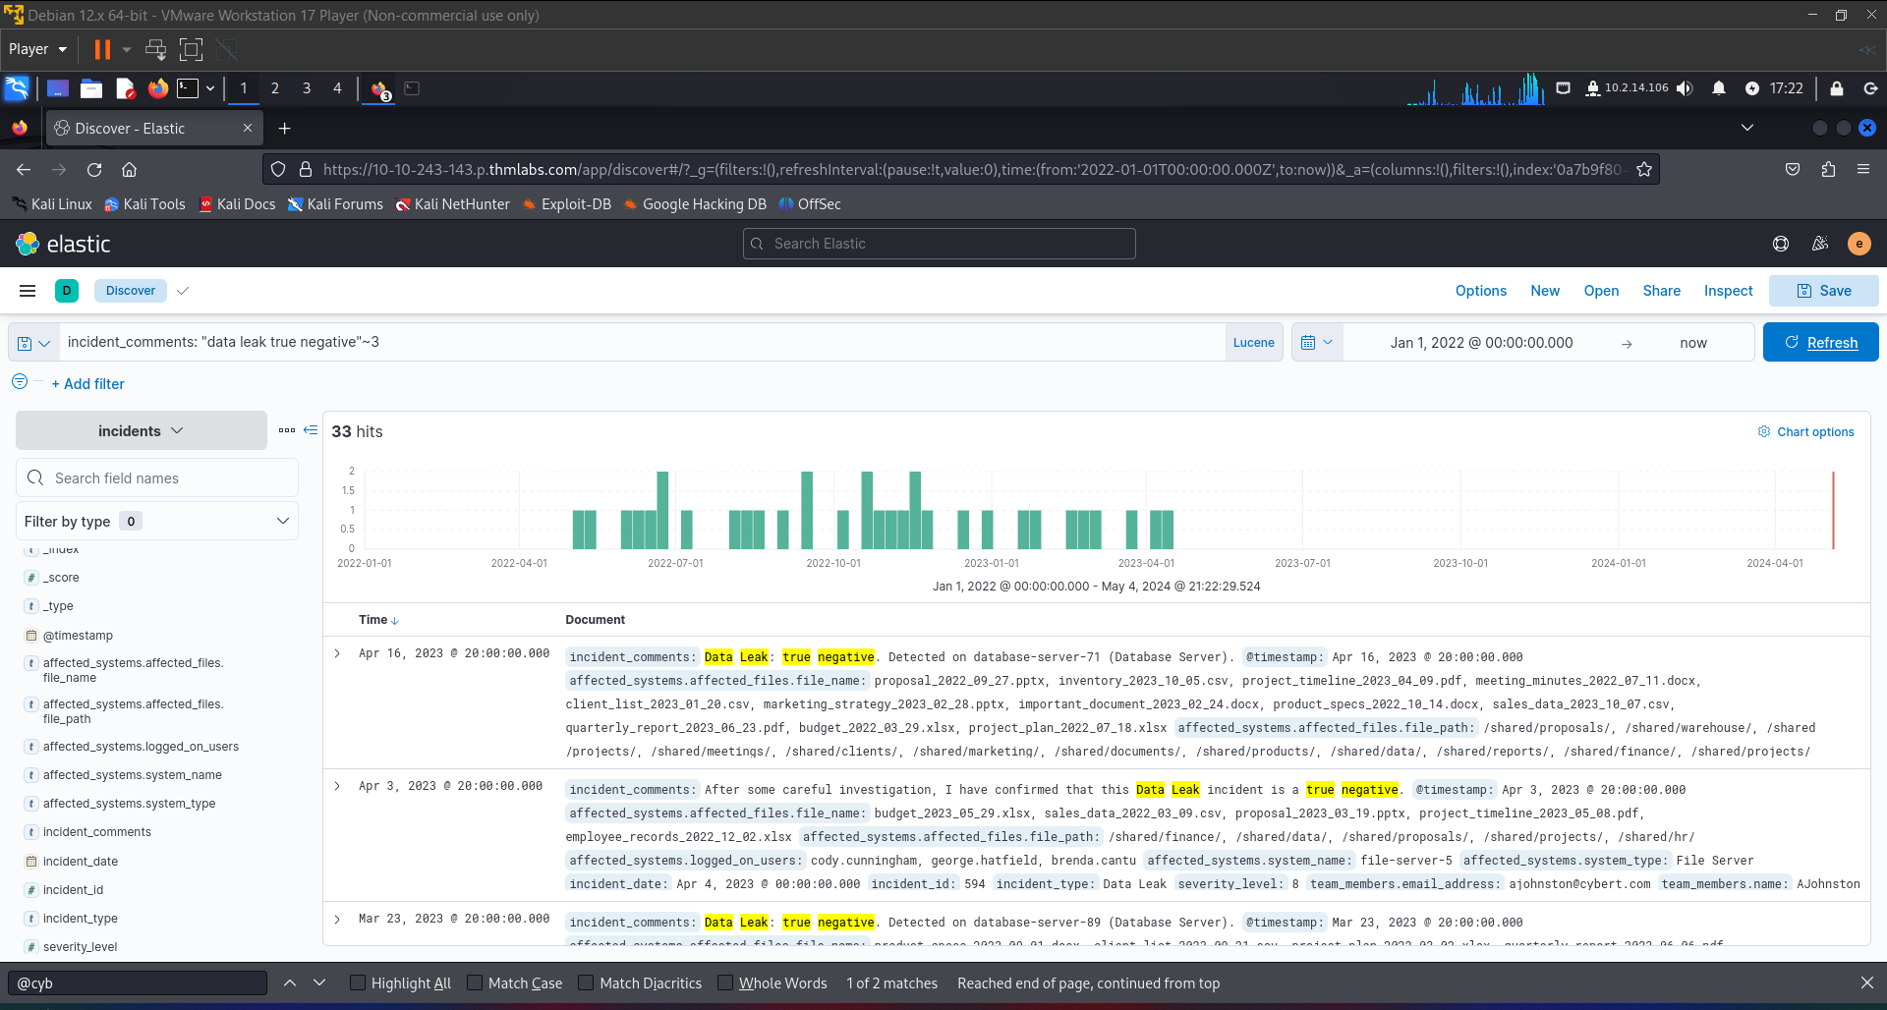

How many incidents has AJohnston investigated that have the words “detected” and “negative” in the comments that are two words apart?  
40

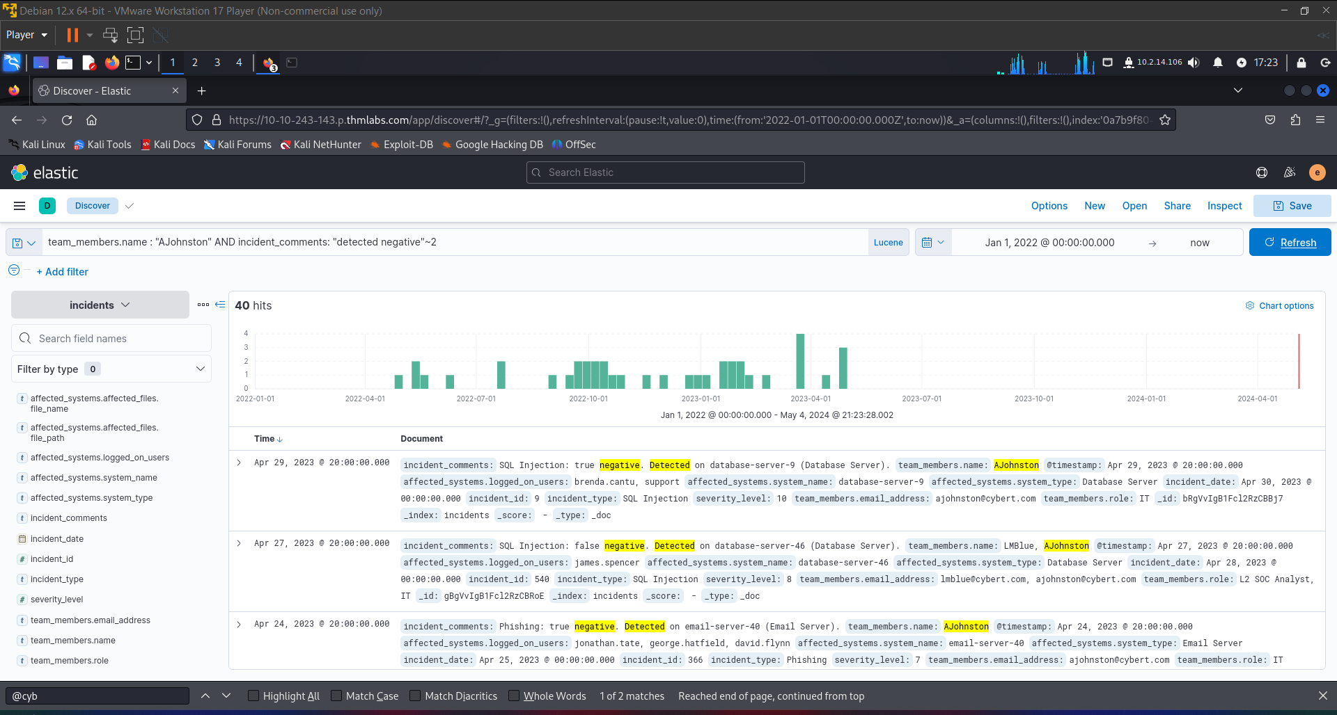

Regular expressions

To use regex in a query, you must wrap your regular expression in forward slashes (/). Let's start with a relatively simple example and use ".*" to match all characters of any length.

**Event_Type:/.*/**

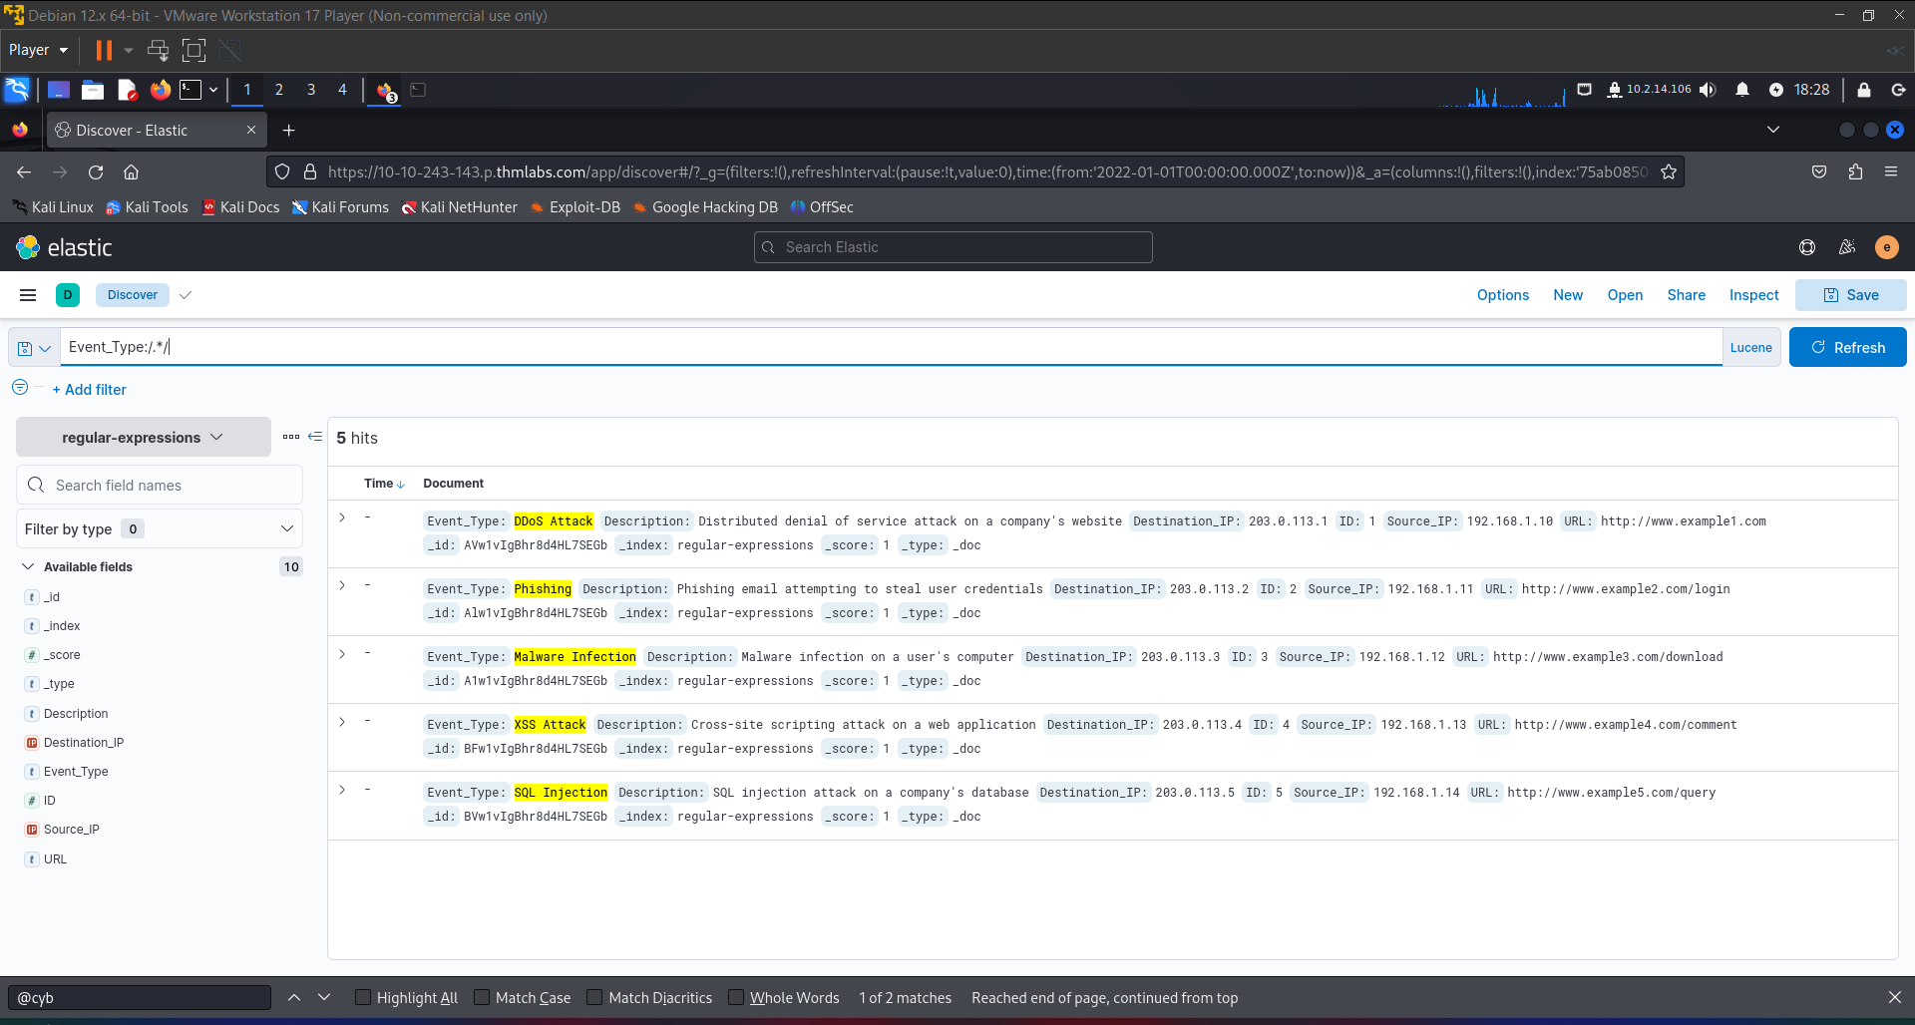

f we want only to return entries that start with the letters "S" or "M", then we could use the following :

**Event_Type:/(S|M).*/**

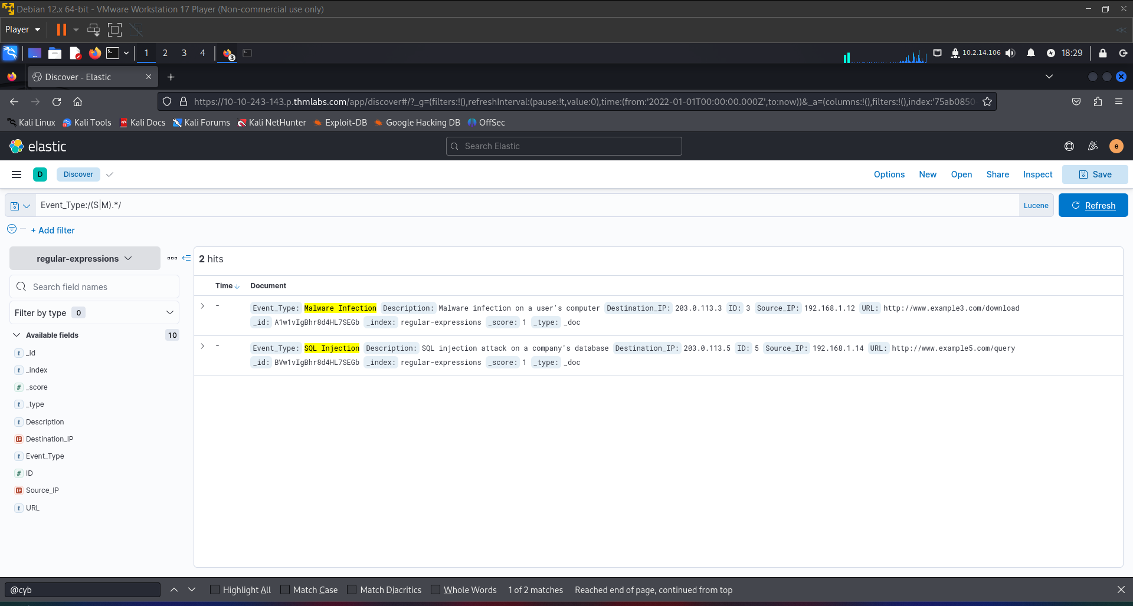

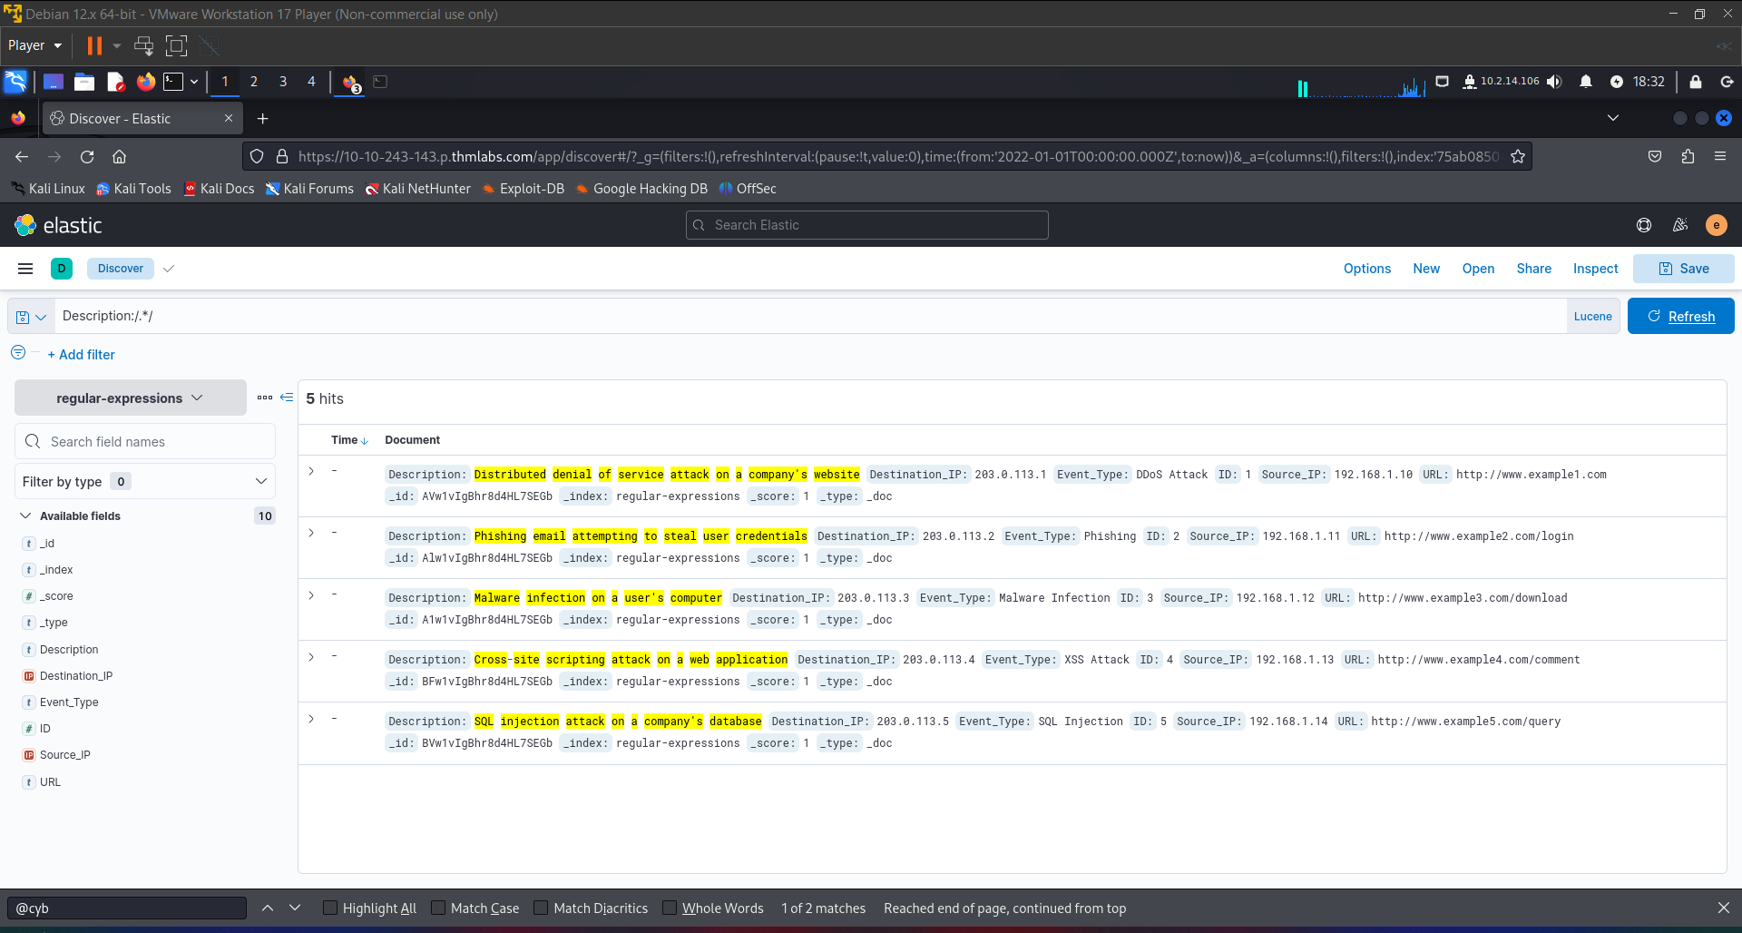

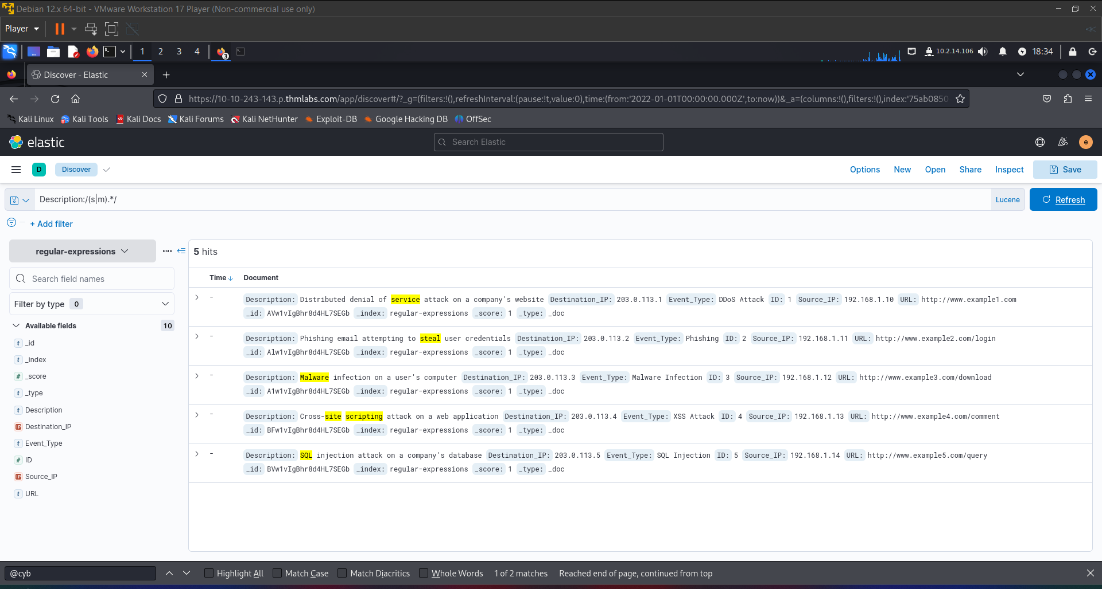

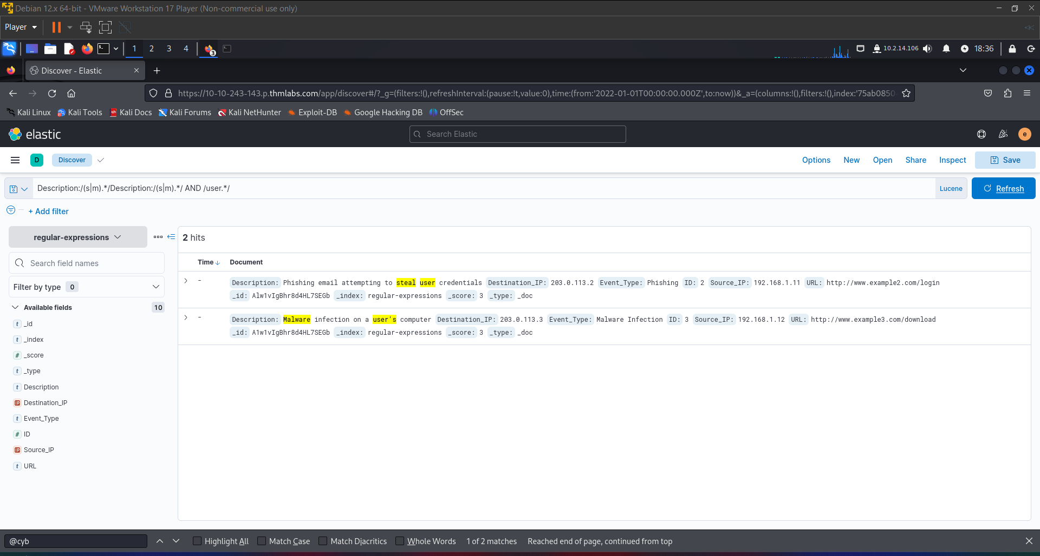

How many incidents are there where a “client_list” file was affected by ransomware?  
70

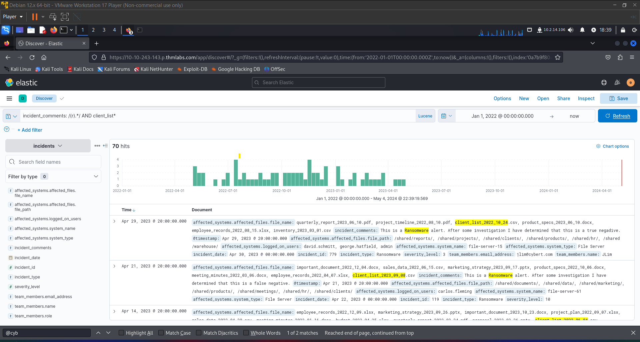

What is the name of the affected system at the earliest incident date that EVenis investigated with a filename containing the word “project”?  
file-server-78

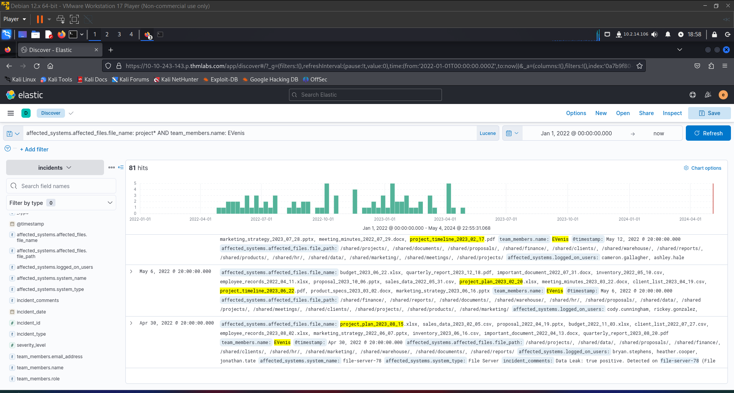

Slingshot

Can you retrace an attacker's steps after they enumerate and compromise a web server?

Slingway Inc., a leading toy company, has recently noticed suspicious activity on its e-commerce web server and potential modifications to its database. To investigate the suspicious activity, they've hired you as a SOC Analyst to look into the web server logs and uncover any instances of malicious activity.

To aid in your investigation, you've received an Elastic Stack instance containing logs from the suspected attack. Below, you'll find credentials to access the Kibana dashboard. Slingway's IT staff mentioned that the suspicious activity started on **July 26, 2023**.

By investigating and answering the questions below, we can create a timeline of events to lead the incident response activity. This will also allow us to present concise and confident findings that answer questions such as:

* What vulnerabilities did the attacker exploit on the web server?
* What user accounts were compromised?
* What data was exfiltrated from the server?

What was the attacker's IP?

Top of Form

Submit 10.0.2.15

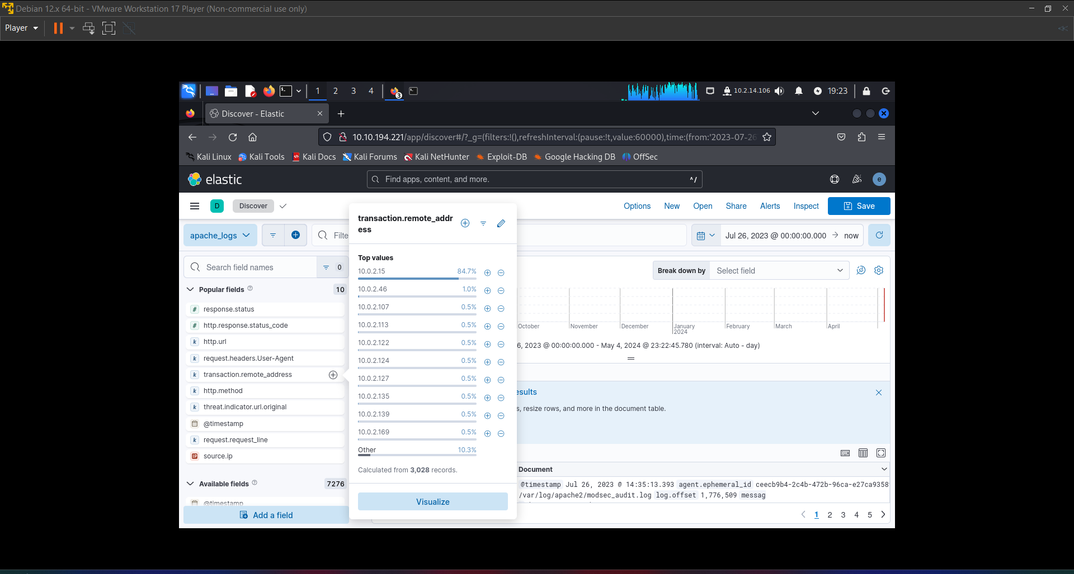

Bottom of Form

What was the first scanner that the attacker ran against the web server?

Top of Form

Submit Nmap Scripting Engine

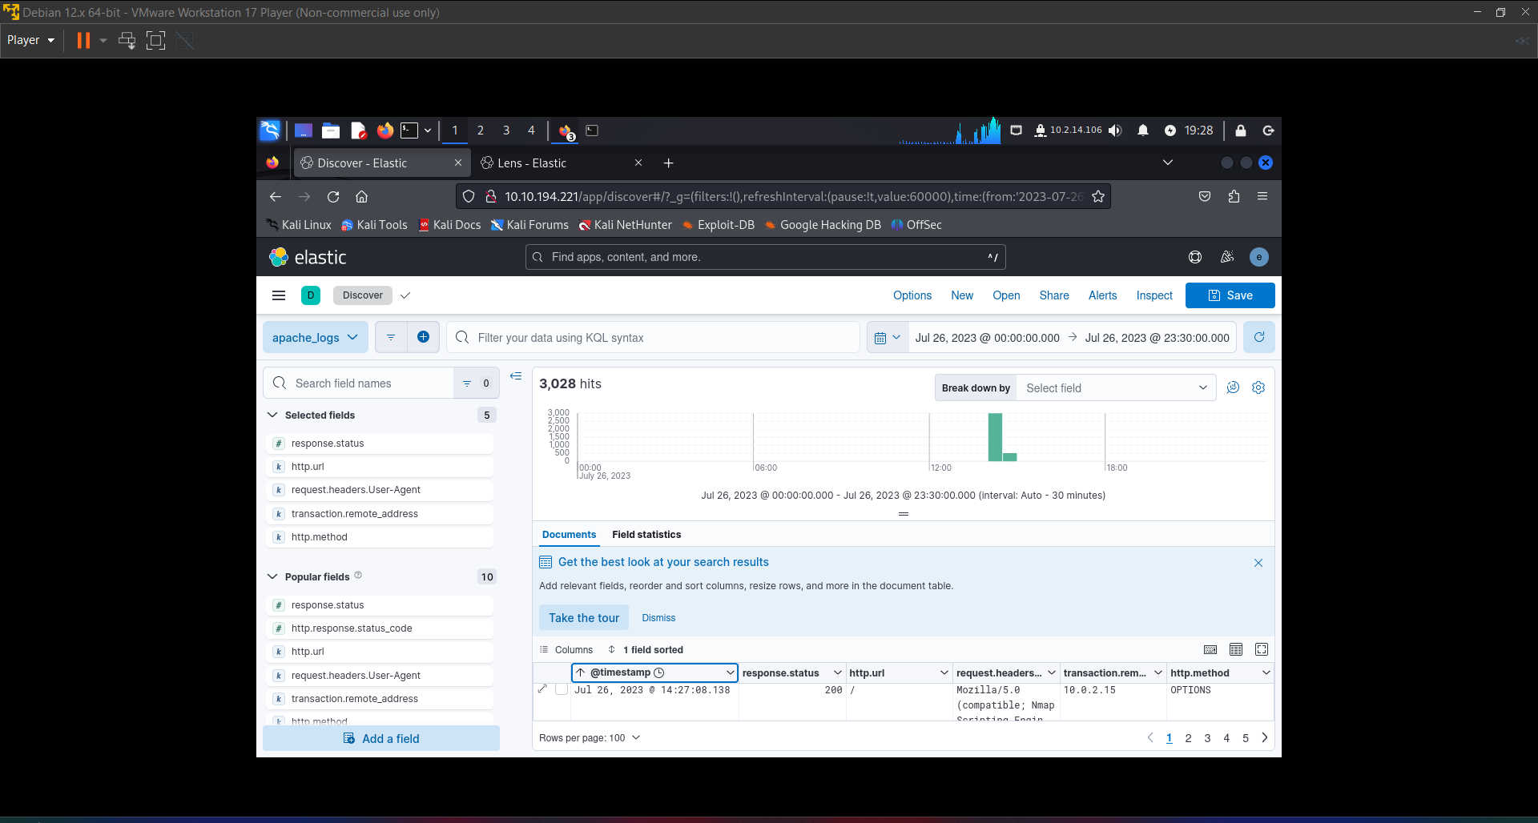

Bottom of Form

What was the User Agent of the directory enumeration tool that the attacker used on the web server?

Top of Form

Submit Gobuster

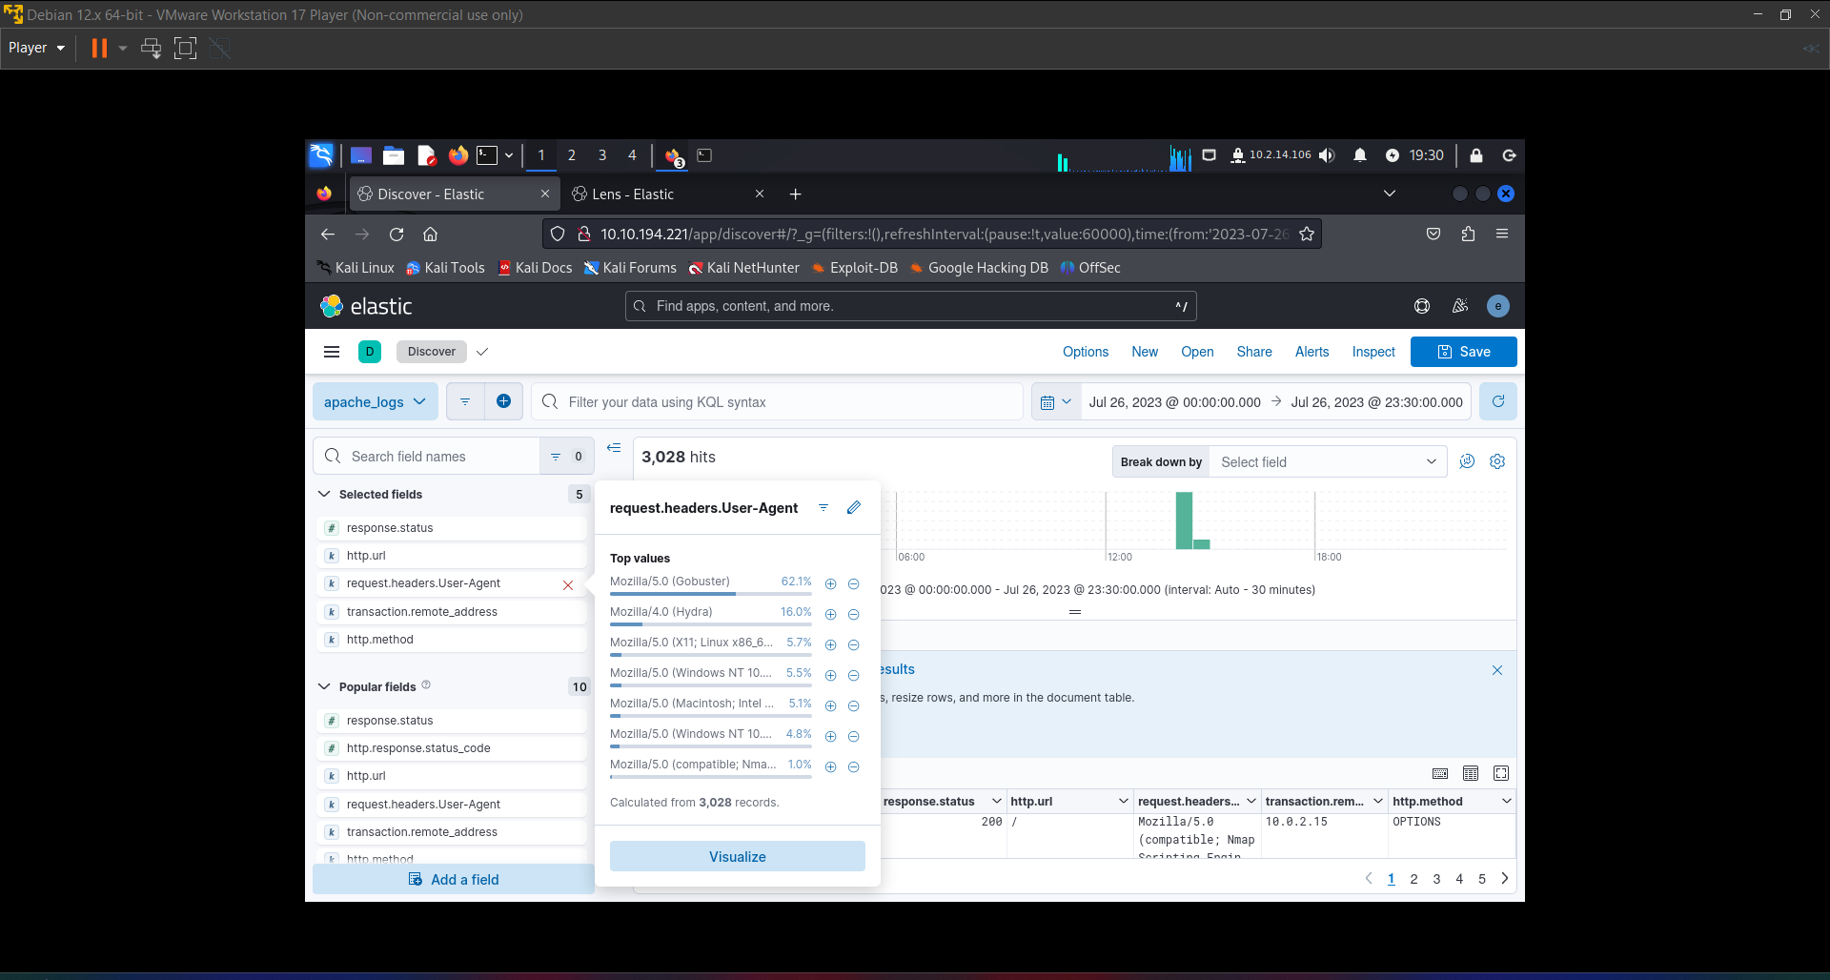

Bottom of Form

In total, how many requested resources on the web server did the attacker fail to find?

Top of Form

Submit 1867

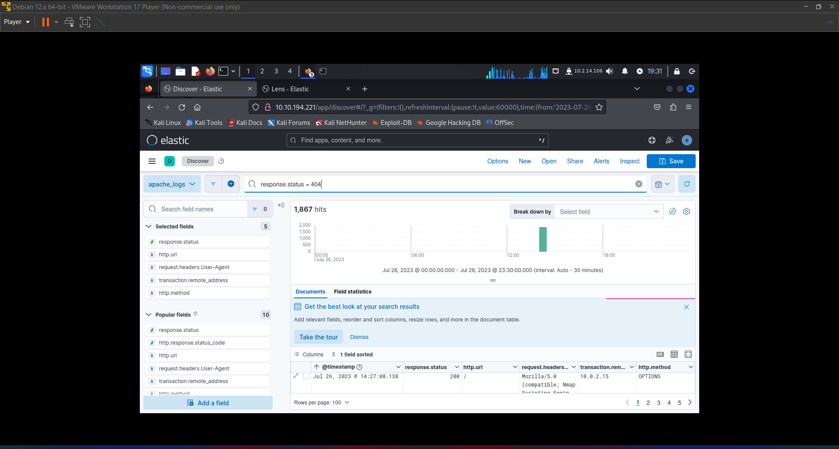

Bottom of Form

What is the flag under the interesting directory the attacker found?

Top of Form

Submit a76637b62ea99acda12f5859313f539a

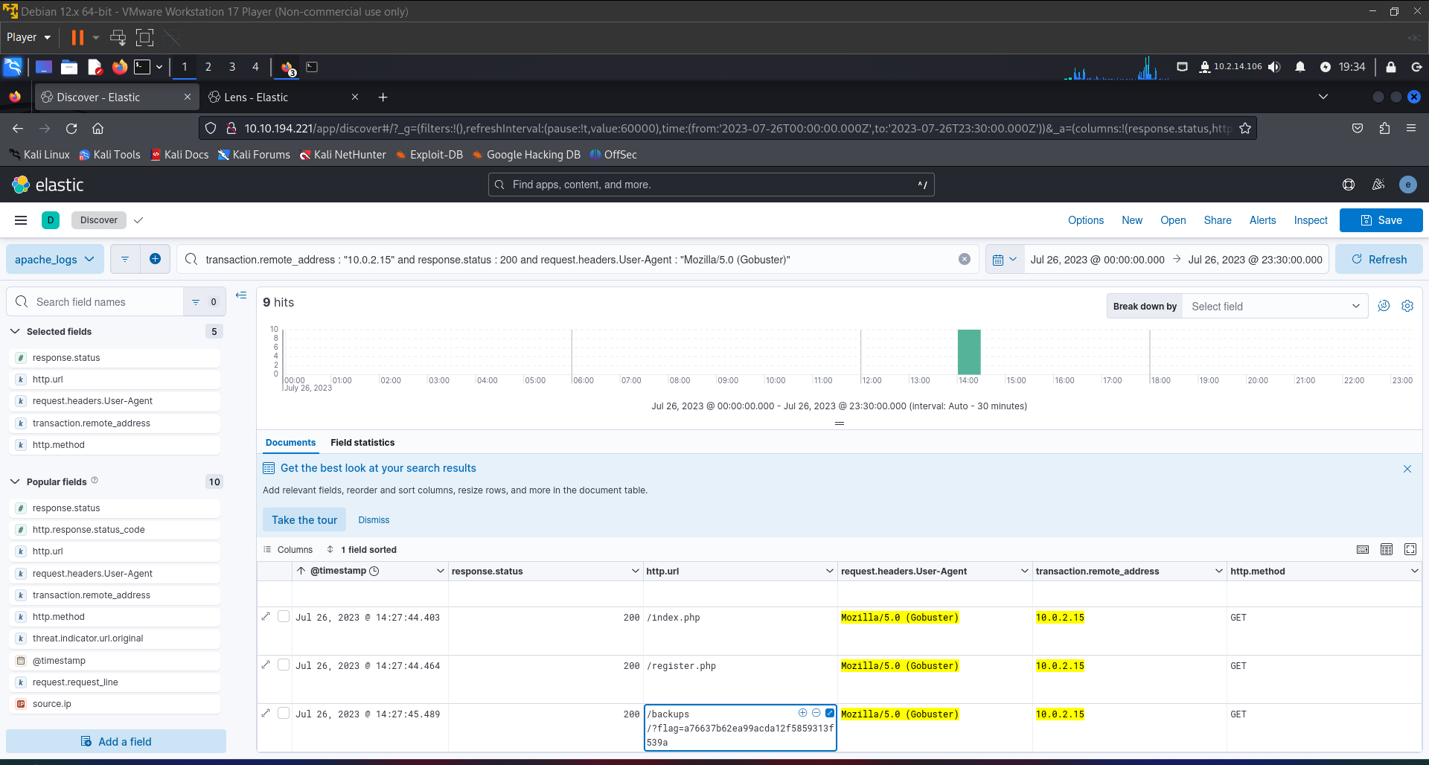

Bottom of Form

What login page did the attacker discover using the directory enumeration tool?

Top of Form

Submit admin-login.php

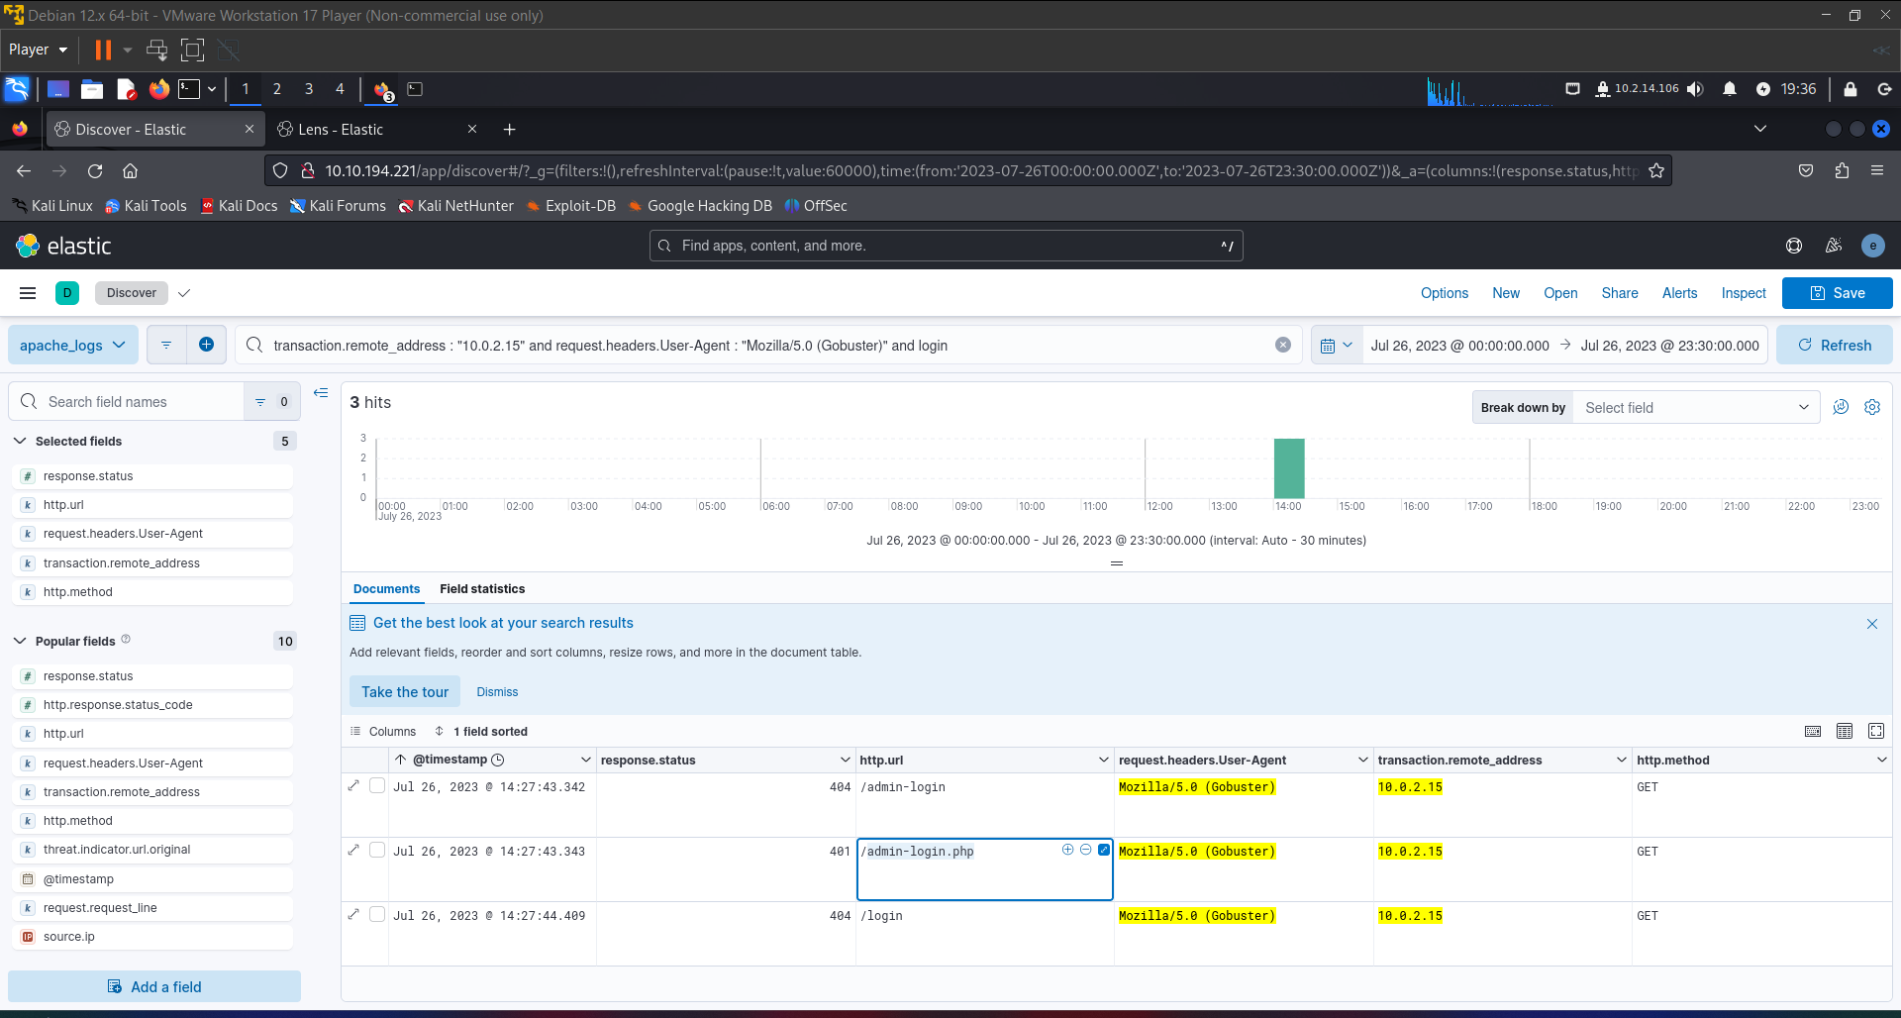

Bottom of Form

What was the user agent of the brute-force tool that the attacker used on the admin panel?

Top of Form

Submit Mozilla/4.0 (Hydra)

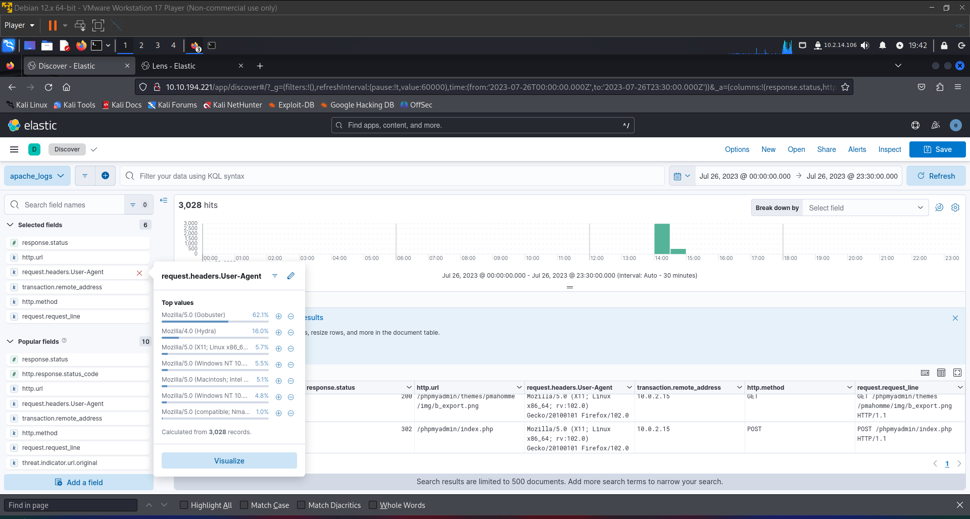

Bottom of Form

What username:password combination did the attacker use to gain access to the admin page?

Top of Form

Submit admin:thx1138

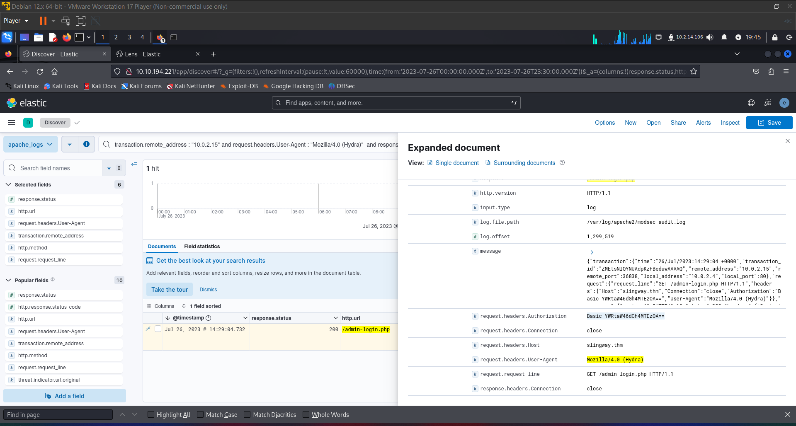

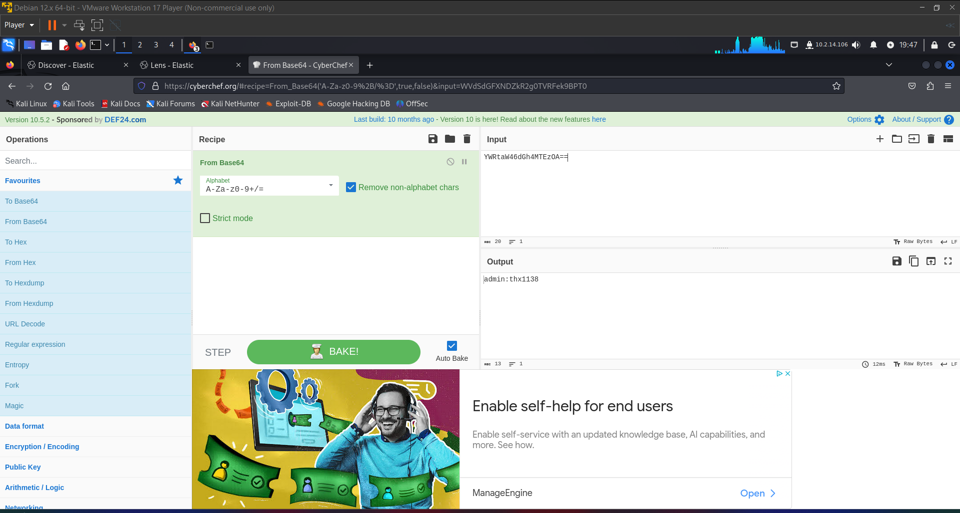

Bottom of Form

What flag was included in the file that the attacker uploaded from the admin directory?

Top of Form

Submit THM{ecb012e53a58818cbd17a924769ec447}

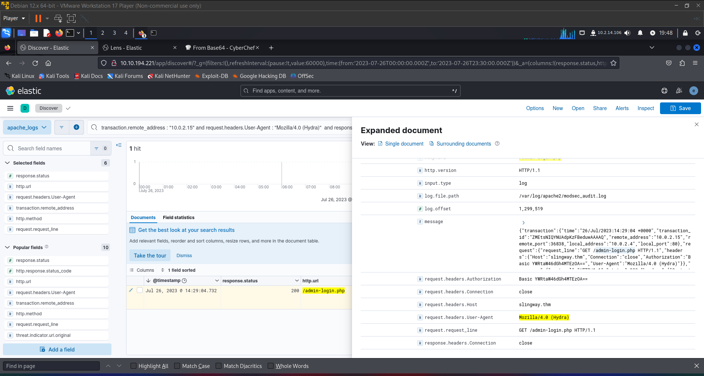

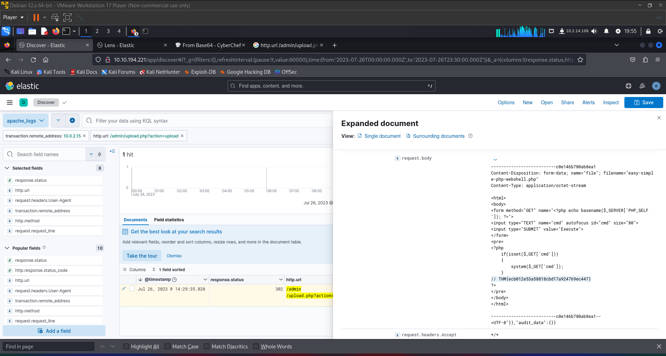

Bottom of Form

What was the first command the attacker ran on the web shell?

Top of Form

Submit whoami

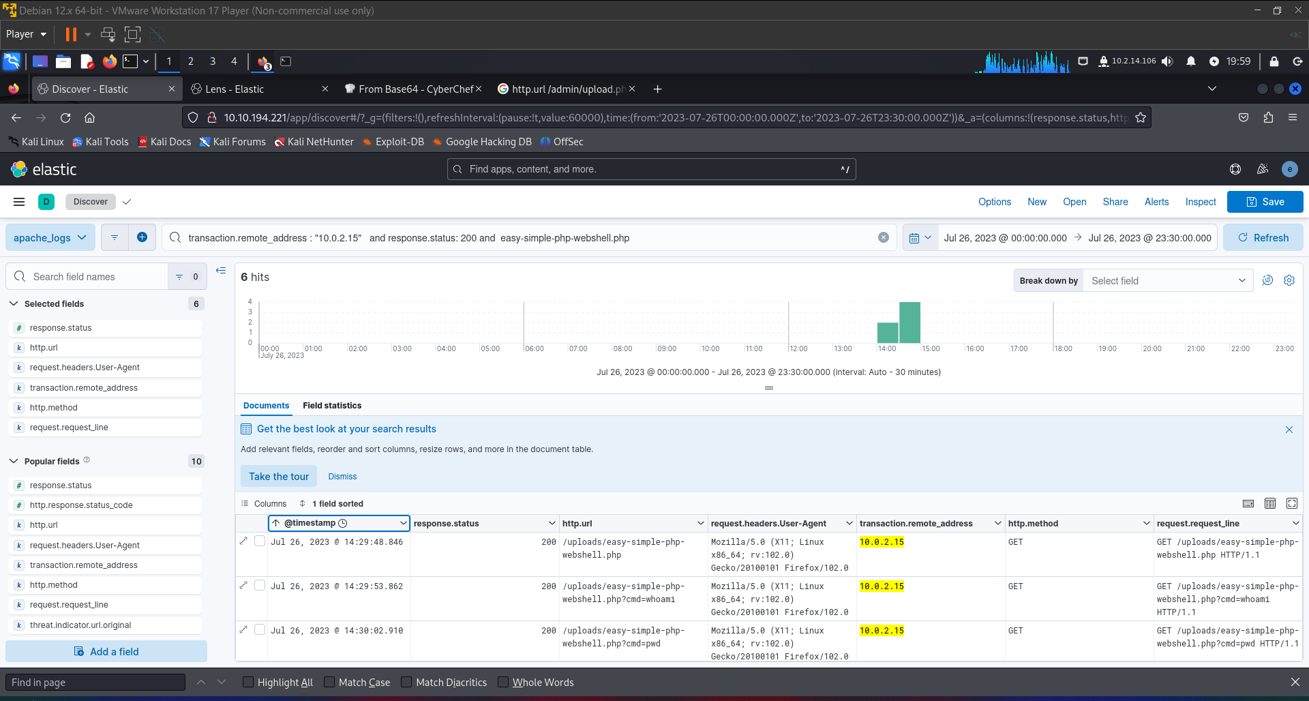

Bottom of Form

What file location on the web server did the attacker extract database credentials from using **Local File Inclusion**?

Top of Form

Submit /etc/phpmyadmin/config-db.php

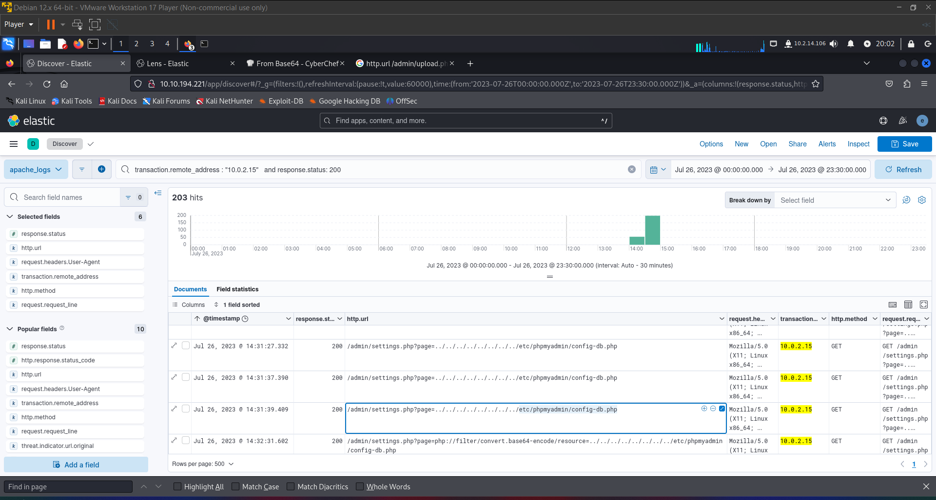

Bottom of Form

What **directory** did the attacker use to access the database manager?

Top of Form

Submit phpMyAdmin

Bottom of Form

What was the name of the database that the attacker **exported**?

Top of Form

Submit customer_credit_cards

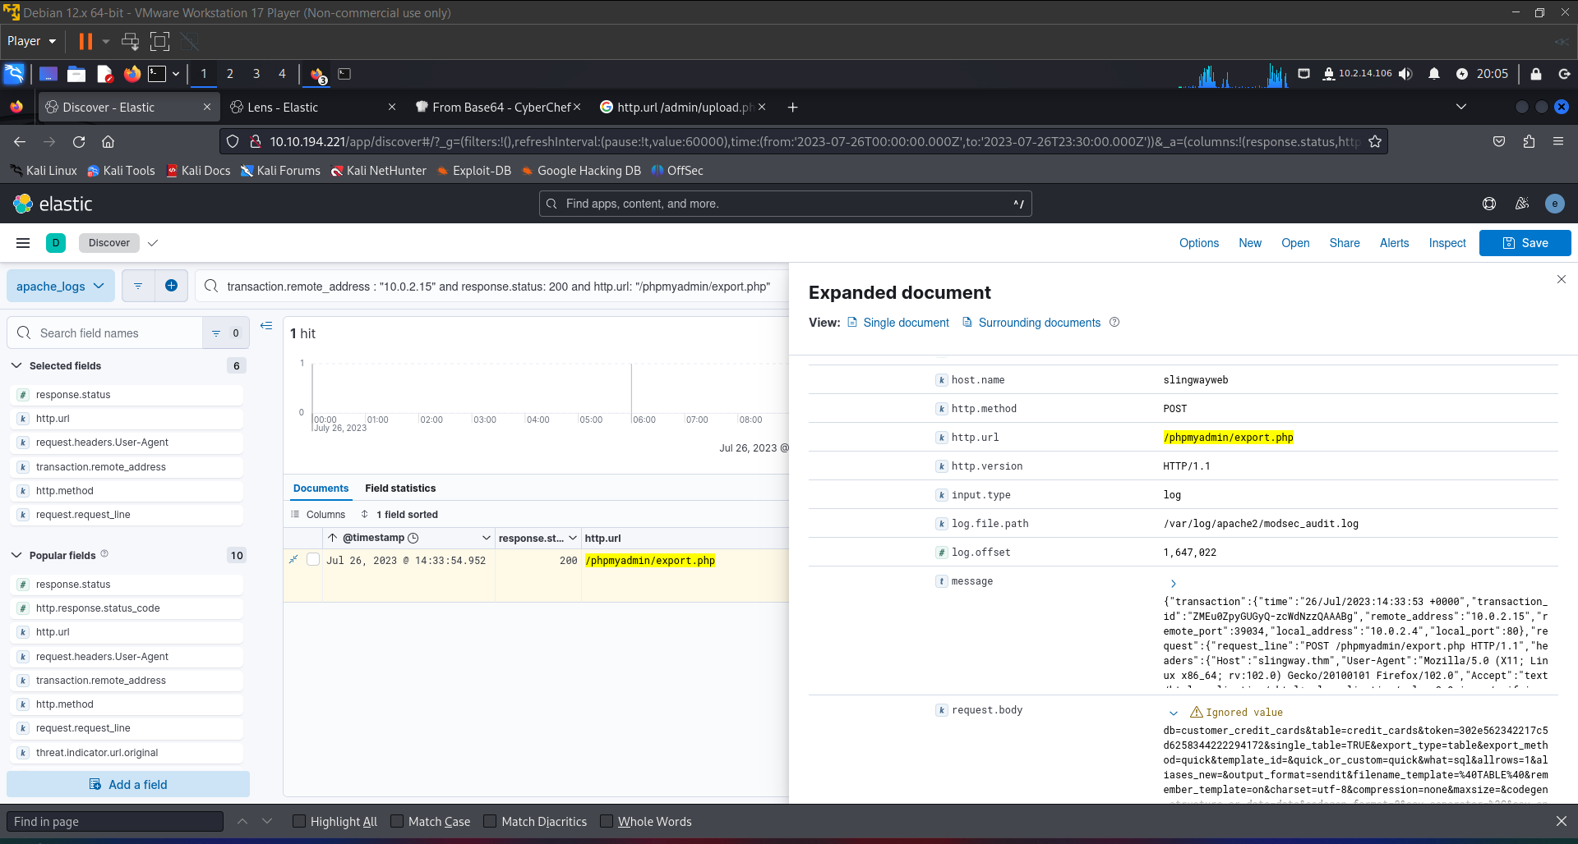

Bottom of Form

What flag does the attacker **insert** into the database?

Submit c6aa3215a7d519eeb40a660f3b76e64c

